Hazards Associated with Hydrogen Infrastructure
Andrzej Rusin*, Katarzyna Stolecka
Silesian University of Technology, Institute of Power Engineering and Turbomachinery
ul. Konarskiego 18, 44-100 Gliwice, Poland

Abstract
Increasing depletion of fossil fuels creates a more intense interest in hydrogen as a renewable, clean-energy source. Combined with the potential of nuclear power and other renewable energy sources, electricity generation from hydrogen seems to be an interesting prospect. However, the pre-requisite for the application of hydrogen is research not only on the possibility of the gas production, use and storage, but also on the safety of each of these stages. Uncontrolled release of hydrogen may indeed pose serious hazards to humans and the environment. The article presents the potential hazard related to hydrogen production, pipeline transport and storage tanks.

Keywords: hydrogen infrastructure, hazards, fire

- Introduction
Depletion of fossil fuel resources and the higher cost of electricity arising therefrom create a greater interest in renewable energy sources. Hydrogen plays a significant role here. Although it is not the basic source of energy, it can be used for energy storage purposes and utilized when and where needed. Therefore, in many countries hydrogen is viewed as an essential alternative to fossil fuels, and research has been conducted on the gas utilization [9, 10].
For the future hydrogen-based economy, the sites of the gas production as well as the methods of storage, distribution and application will have to be specified. It will be possible to produce hydrogen in large centralized plants or in smaller installations built to meet own needs of certain companies and/or factories. Large-scale production will require a distribution network made of pipelines and tanks that will enable hydrogen delivery to the utilization sites (Fig. 1) [5,7,10]. Large-scale implementation of the hydrogen infrastructure into economy will require an analysis of a number of technological and economic aspects as well as issues related to the safety of humans and of the environment. Obviously, the hazards posed by hydrogen arise from its physiochemical properties. The gas is highly flammable, with a wide range of flammability and a low minimum ignition energy, and, in the event of uncontrolled release and ignition of hydrogen, considerable amounts of energy may be released due to a fire or an explosion [5,6].
.

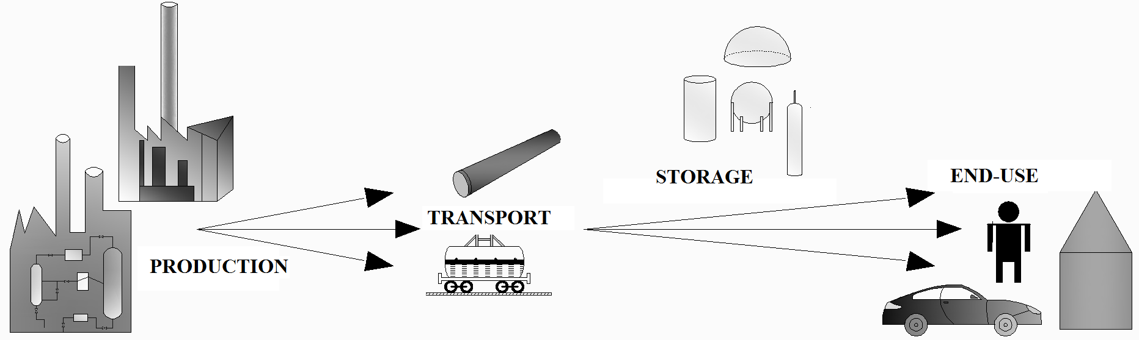
Fig. 1. Hydrogen infrastructure

- Hydrogen infrastructure
The hydrogen infrastructure elements will depend on the processes of the gas production, storage and end-use (Fig. 2). The following components and equipment elements may be mentioned here: tanks, pipelines, pipeline fittings, etc. Hydrogen contained or flowing in them may be in the gaseous or liquid state, and each element of the infrastructure should be made with extreme care to ensure the safety of use. Hydrogen may be produced on a vast scale in large plants based on renewable energy sources and then transported through a network of tanks and pipelines to utilization or storage sites. In the case of small-scale production, however, the gas may be used entirely on the production site. There is no need then to build a large transmission network – some installation elements will only be required to transport hydrogen within the plant itself. In its gaseous or liquid form, hydrogen may be stored in special tanks and used when and where needed. For example, end-users could use it to drive their cars [5,6].
The most common cause of hydrogen-related hazardous failures is mechanical damage or damage due to material defects, corrosion, enhanced embrittlement of storage tanks in low temperatures and human errors. The effects of a hydrogen installation failure, beside a fire, include the consequences of explosions and the BLEVE phenomenon, causing damage due to the impact of pressure waves and of the flying missiles of ruptured tanks [2,3,6,10].

TRANSPORT
large-scale hydrogen production
installations: tanks, pipes,
small pipelines

large-scale production
long-distance transport
pipelines with fittings
railway tank cars and road tankers, cargo ships
hydrogen production in small plants
installations: tanks, pipes,
small pipelines
local transport:
tanks, pipes,
pipelines
PRODUCTION
storage tanks for liquid and
gaseous hydrogen
STORAGE
END-USE
refuelling stations
cars, fuel cells
Fig. 2. Hydrogen-based economy elements

- Hazards related to the use of hydrogen
The precondition for meeting the assumptions of the future hydrogen-based economy is the development and construction of appropriate infrastructure. Each of its elements can create potential hazards to humans and the environment, especially in the event of a failure and uncontrollable release of hydrogen into the atmosphere. Naturally, a detailed analysis of all of them is impossible. This in particular concerns installations and equipment whose structural properties are not yet fully known.
Due to hydrogen great capacity for leakage, wide range of flammability and low ignition energy combined with the potential for causing enhanced embrittlement of metals, the safety of the gas utilization includes a number of issues related to the correctness and safety of the processes involved with it. The hazards related to the use of hydrogen may generally be divided into sevral categories [7]:
Physiological hazards, which are related to the effect of hydrogen on humans. A reduction in oxygen concentration in air due to hydrogen may cause breathing problems (dyspnea). If a storage tank or a pipeline gets damaged or if hydrogen is released into the atmosphere, a fire or an explosion may occur. The dangerous consequences of these phenomena for humans may be the direct impact of flames and thermal radiation in the case of fire and the impact of the pressure wave and of flying bits of ruptured tanks in the case of an explosion. Another hazard posed by the gas to humans are cryogenic burns of the skin caused by exposure to large amounts of condensed, cooled hydrogen (hypothermia may occur).
Physical hazards, which are related to properties of metals and to the phenomenon of hydrogen embrittlement. Depending on temperature and pressure, as well as on the time of exposure to hydrogen and the state of the metal, degradation of the metal mechanical properties occurs damaging tightness and causing leakage. The hydrogen embrittlement phenomenon intensity gets higher in the range of temperatures of 200-300 K. This process may be prevented by the use of oxygen coatings, application of appropriate metal alloys, elimination of stress concentration and introduction of special additives to hydrogen.
Chemical hazards, which are related to the properties of hydrogen. The gas is characterized by very low ignition energy – 0.02 mJ. Because of that, electrical or heat-generating appliances or any open flame sources should be isolated from the hydrogen installation operation site. The gas is also characterized by a wide range of flammability, which adds to its hazardous nature.
- Scenarios of hazardous events
The hydrogen-related scenarios of hazardous events depend on the elements applied in the installation and on the processes involved in the gas production, storage, etc. The most damage-prone elements of hydrogen installations are tanks, pipelines and pipes. The effects of a potential failure depend on the way it proceeds. For example, due to a complete and extreme rupture, the tank contents may be released entirely in a very violent way. If the pipeline is damaged partially, hydrogen may be released less violently but continuously, i.e. the gas will keep flowing out until its inflow is stopped by closing the valves and cutting off the damaged segment of the pipeline.
The basic hazards created due to the failure of these elements are as follows [3,4,6,7,9]:
- hydrogen release, which may displace oxygen from the room and cause dyspnea to humans;
- low-temperature hydrogen release, which may cause cryogenic burns;
- fire, which is related to uncontrolled release and ignition of hydrogen. This phenomenon presents a hazard to humans due to the direct impact of the flame or thermal radiation. One of its forms is the jet fire, characterized by a long steady flame arising if highly-pressurized hydrogen is released, e.g. through a hole in the pipeline wall.
- the BLEVE phenomenon – i.e. the boiling liquid expanding vapour explosion. This phenomenon may arise in the event of a hydrogen tank rupture. The hazard posed to humans is related to the impact of the pressure wave and of flying bits of the ruptured tank, as well as to direct thermal radiation and contact with the flame – if the phenomenon is accompanied by a fire in the form of a fireball.
- explosion, which may occur due to uncontrolled release of hydrogen from a tank or pipeline. Here, the hazard posed to humans and the environment is related to the impact of the pressure wave and of flying bits of the ruptured tank.
Example effects of disasters caused by hydrogen release are presented below.
Fig. 3 shows the range of hazard zones with an increased thermal radiation level in the case of a jet fire of hydrogen released from a pipeline with the diameter d = 150 mm through a 5-cm hole in a 30-metre long transmission segment. The gas outflow is vertical and horizontal to the transmission pipeline axis (Fig. 3 and Fig. 4, respectively). The calculations were made using the PHAST program for hydrogen with the pressure of 0.5 MPa and temperature of 20ºC. The air temperature and the wind speed are assumed at 15ºC and 1 m/s, respectively, [8].

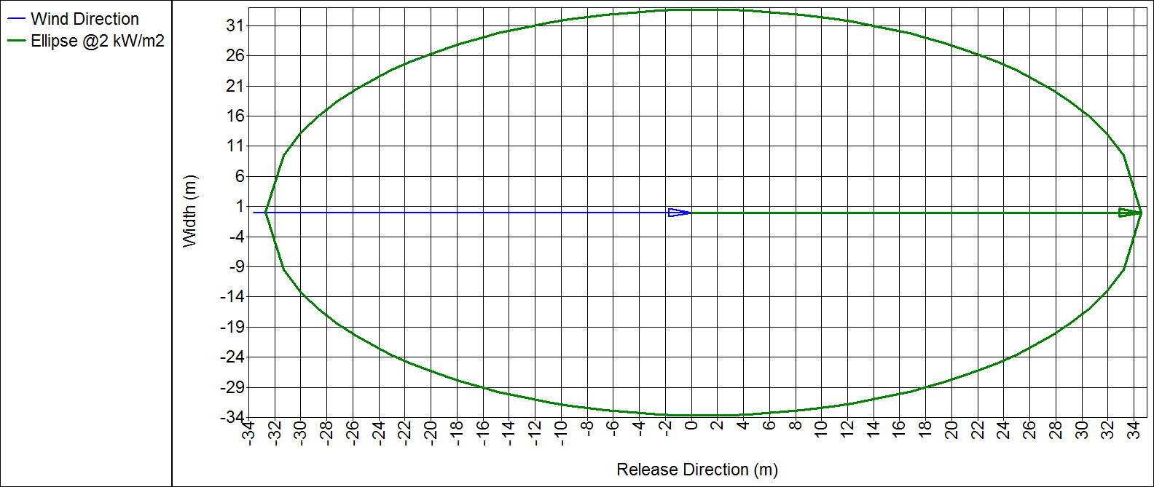
Fig. 3. Hazard zone ranges (vertical outflow)
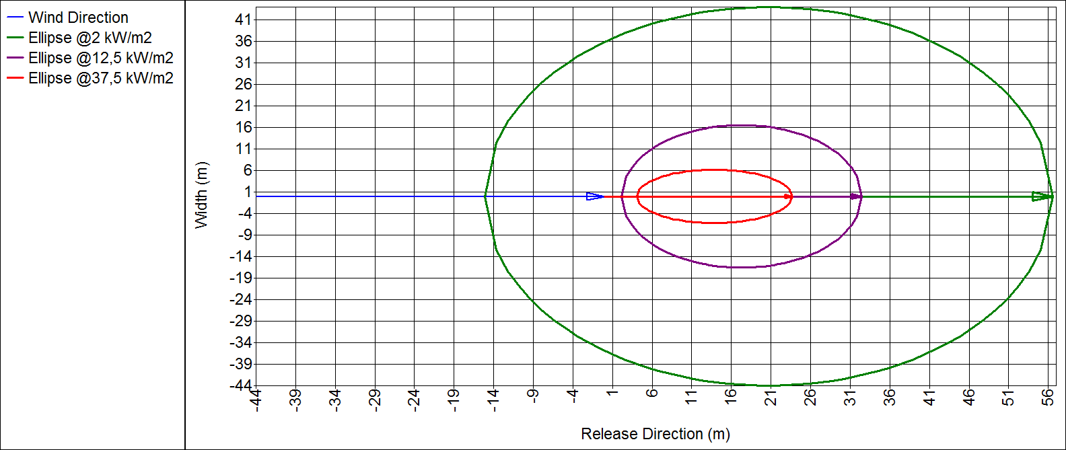
Fig. 4. Hazard zone ranges (horizontal outflow)

Analysing the figures presented above, it can be observed that the zone with the highest, lethal thermal radiation value of 37.5 kW/m² will arise only in the case of the hydrogen horizontal release due to the pipeline damage, and its range will reach about 24 metres. The zone with the thermal radiation value of 2 kW/m², which may be considered as fairly safe to humans because this level of thermal radiation does not have a negative impact on them [2], extends over an area with the range of about 35 and 56 metres (vertical and horizontal outflow, respectively).
Another example of a hazardous failure related to the use of hydrogen is a disastrous, complete rupture of a railway tank car transporting liquid hydrogen. In the adopted scenario of the occurrence of a hazardous event it is assumed that 100 t of liquid hydrogen are transported at the pressure of 7 bar and temperature of -253.2ºC. Due to the tank car rupture, the liquid gas is released, which is followed by its evaporation and delayed ignition causing a phenomenon defined as the pool fire. It is assumed in the calculations that the air temperature and the wind speed are 20ºC and 5 m/s, respectively, [8].

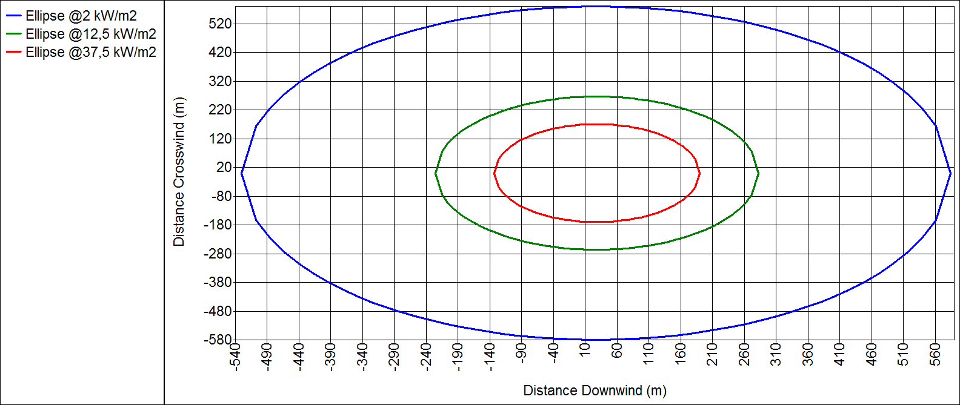
Fig. 5. Hazard zone ranges (railway tank car)

Analysing the figure presented above, it can be observed that the effects of the disaster are much more serious than the release and ignition of hydrogen from a transmission pipeline. The range of the zone of hazard to human life due to high radiation is about 189 metres. The safe area with no hazard to humans will be more than 585 m away from the site of the railway tank car failure.
Fig. 6 presents the effects of an explosion of a tank containing 2000 kg of hydrogen under the pressure of 450 bar. Such a tank may be used to store or transport hydrogen. The analysis is performed assuming the wind speed of 1 m/s [8].

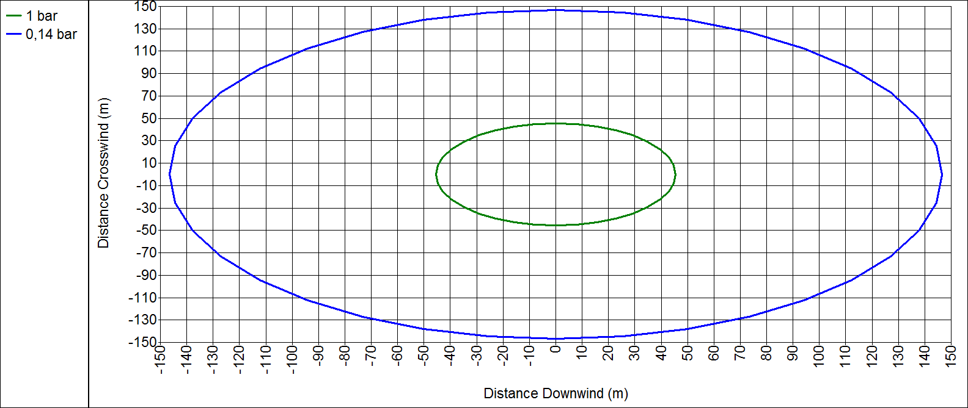
Fig. 6. Hazard zone ranges (tank explosion)

An analysis of the figure indicates that in the event of an explosion of 2 t of hydrogen released from a ruptured tank, no zone with the pressure wave value exceeding 483 kPa, which can cause internal fatal injuries, will arise. The range of the zone with a pressure wave value causing damage to a human's eardrum will be about 150 metres, and of the zone causing damage to lungs – about 45 metres.
- Conclusions
Due to its properties, hydrogen seems to be the energy carrier of the future. However, it may also pose serious hazards. Therefore, the infrastructure serving the needs of the gas safe production, storage and distribution should be analysed in terms of potential risk and hazards it may present to humans and the environment. The results of the example analyses of the cases considered herein show that the size of the risk and hazards will be related to factors such as the amount of hydrogen involved in the disaster, its parameters and the type of failure.
In the event of a hydrogen leakage through a 5 cm hole in a hydrogen installation pipe with the diameter of 150 mm, the range of the zone with the dangerous level of thermal radiation of 37.5 kW/m² posing hazard to humans will be 24 metres (if the gas outflow is horizontal). This hazardous zone will become substantially larger (about 8 times) if a failure occurs of a tanker carrying 100 t of hydrogen. In the case of an explosion of a hydrogen storage or transport tank, the range of the zone presenting hazard to humans with the pressure wave value of 100 kPa, corresponding to damage to human lungs, will be about 45 metres.
Designing elements of hydrogen production, transport and storage installations, it is absolutely necessary to conduct a risk analysis and determine the range of zones creating potential hazards.
Acknowledgements
The conclusions described herein are the effect of research conducted within the project “Energy storage in the form of hydrogen in salt caverns”, subsidized from the funds of the National Centre for Research and Development (NCBiR) within the GEKON programme; CONTRACT: GEKON1/2/214140/23/2015
References
[1] Gerboni R., Salvador E., Hydrogen transportation systems: Elements of risk analysis, Energy 34 (12) (2009) 2223-2229.
[2] LaChance J., Risk-informed separation distances for hydrogen refuelling stations, International Journal of Hydrogen Energy 34 (14) (2009) 5838-5845.
[3] Li Z.., Pan X., Sun K., Ma J., Comparison of the harm effects of accidental releases: Cryo-compressed hydrogen versus natural gas, International Journal of Hydrogen Energy 38 (25) (2013) 11174-11180
[4] Li Z.., Pan X., Meng X., Ma J., Study on the harm effects of releases from liquid hydrogen tank by consequence modelling, International Journal of Hydrogen Energy 37 (22) (2012) 17624-17629
[5] Markert F., Nielsen S.K., Paulsen J.L., Andresen V., Safety aspects of future infrastructure scenarios with hydrogen refuelling stations, Energy 32 (13) (2007) 2227-2234
[6] Moonis M., Wilday A.J., Wardman M.J., Semi-quantitative risk assessment of commercial scale supply chain of hydrogen fuel and implications for industry and society, Process safety and Environmental Protection 88 (2) (2010) 97-108
[7] Najjar Y.S.H., Hydrogen safety: The road toward green, International Journal of Hydrogen Energy 38 (25) (2013) 10716-10728
[8] PHAST v6.7 Software
[9] Rigas F., Sklavounos S., Evaluation of hazards associated with hydrogen storage facilities, International Journal of Hydrogen Energy 30 (13-14) (2005) 1501-1510
[10] Rosyid O.A., Jablonski D., Hauptmanns., Risk analysis for the infrastructure of hydrogen economy, International Journal of Hydrogen Energy 32 (15) (2007) 3194-3200

