Performance of the PEM fuel cell module. Part 2. Effect of excess ratio and stack temperature
Janusz T. Cieśliński*, Tomasz Kaczmarczyk, Bartosz Dawidowicz
Gdańsk University of Technology,Narutowicza 11/12, 80233 Gdańsk,Poland
* Corresponding author: jcieslin@pg.gda.pl

Abstract
The paper describes a fuel cell based system performance under different thermal conditions. The system is based on two fuel cell units (1,2 kW each, produced by Ballard Power Systems Inc. and called Nexa), DC/DC converter, DC/AC inverter, microprocessor control unit, load unit, bottled hydrogen supply system and set of measurement instruments. In present study steady-state operation of the PEM fuel cell system at different values of air excess ratio and different stack temperature was investigated. The load of the system was provided with the aid of the set of resistors. Obtained results show that the net power of the system does not depend on the air excess ratio within the range of $λ_{O_{2}}$from 1.9 to 5.0. The polarization curves of the fuel cell module showed that the fuel cell performance was improved with increase stack temperature within the range of 30°C to 65°C.

Keywords: Proton exchange membrane fuel cell, Hydrogen, Operating temperature, Excess ratio

- Introduction
Todays priority goal for energy conversion engineers is to develop high efficient, low emission energy systems. One of the promising technology seems to be fuel cells which convert directly chemical energy into electrical energy. Energy conversion with fuel cell application is very efficient with small negative impact on the environment. Fuel cells can be used either in power plants as well as in dispersed generation [1].
Polymer Electrolyte Fuel Cell (PEFC) also known as Proton Exchange Membrane or Polymer Electrolyte Membrane (PEM) fuel cells for many years have been used in small scale mobile solutions as energy source for laptop computers, small transport devices such as forklifts or military equipment. Because of constant development of fuel cell which leads to lower prices and higher efficiencies this technology can also be used in large stationary applications. PEMFC are viewed as one of the most environmentally friendly propulsion systems for automotive travel in the future [2,3].
Cell performance for any fuel cell is a function of pressure, temperature, reactant gas composition and utilization [1]. In order to ensure long-life operation and durability of PEM fuel cells [4] the ratio between the oxygen consumed due to the electrochemical reaction and the oxygen flow rate supplied to the fuel cell must fulfil the stoichiometric relation required to produce the current demanded, otherwise a phenomenon called oxygen starvation occurs [5]. When starved from fuel or oxygen, the performance of fuel cells degrades and cell voltage drops. The oxygen starvation phenomenon occurs when oxygen partial pressure falls below a critical level at any location at the cathode [6]. This results in a rapid cell voltage decrease and can cause a burn through the surface of the membrane. Therefore the regulation of the oxygen excces ratio - defined as the ratio of the oxygen entering the cathode and the oxygen reacting in the fuel cell stack [6], is a crucial issue [7,8]. The desired value of the oxygen excces ratio depends on the fuel cell itself and on the operating objective. To guarantee safety and high efficiency of the stack in the literature value of $λ_{O_{2}}=2$is proposed [9]. Notice that positive deviations of $λ_{O_{2}}$above the reference imply lower efficiency [1,8]. Zhang et al. [10], in turn, presented the effects of the temperature and the equivalent internal resistance on the output characteristics of the PEM fuel cells. The proposed semi-empirical dynamic model is constructed based on the measurements from a NexaTM PEM fuel cell power module under different load conditions, and the model has been validated by static as well as dynamic tests. The effects of temperature and variations in the internal impedance under different load conditions have been studied. The results have indicated that the model provides an accurate representation of the dynamic and static behaviors of the fuel cell power module. Xue et al. [11] considered the effect of temperature transient behaviour in their modeling of PEMFC performance. Their model incorporates the complicated temperature, gas flow and capacitance effects under operating conditions. The focus was on the dynamic and transient properties of the system. They used the control volume approach to develop a set of equations that govern the system dynamics. The fuel cell system was divided into three control volumes, the anode channel, the cathode channel, and the fuel cell body. For each control volume, the establishment of a lumped-parameter dynamic model was realized using a combination of intrinsic mechanistic relations and empirical modelling. Recently, Beicha and Zaamouche [12] developed a model to predict the efficiency and power of the fuel cell as a function of operational parameters of the cell, like temperature, partial pressures and membrane humidity.
The primary aim of this study was to provide steady-state characteristics of the Nexa module (1.2 kW) for different values of air excess ratio and operating temperature for given load (set of resistors).

- Fuel cell module and apparatus
The Nexa power module produces unregulated DC power for interfacing with external power conditioning equipment. A single fuel cell element produces about 1 volt at an open-circuit and about 0.6 volts at full current output. The Nexa fuel cell stack has a total of 47 fuel cells in series. The geometric area of the single cell is equal to 120 cm². The unit is equipped with air compressor and cooling blower.
Main specifications of the fuel cell module are summarized in Tab. 1.

Tab. 1. Technical specifications of the Nexa fuel cell module [13]
Performance | - Rated net output  - Heat dissipation  - Current  - Voltage  - Lifetime | 1200 W  1600 W  46 A DC  26 V DC  1500 hours
Fuel | - Gaseous hydrogen  - Supply pressure | 99.99%, dry  0.7 to 1.72 MPa
Operating environment | - Ambient temp.  - Humidity | 3 to 40ºC  0 to 95% non -condensing
Emissions | - Pure water (vapor and liquid)  - CO, CO₂, NO_{x}, SO₂ particulate | Maximum 870 ml/h  0 ppm
View of the tested PEM fuel cell system is shown in Fig. 1.

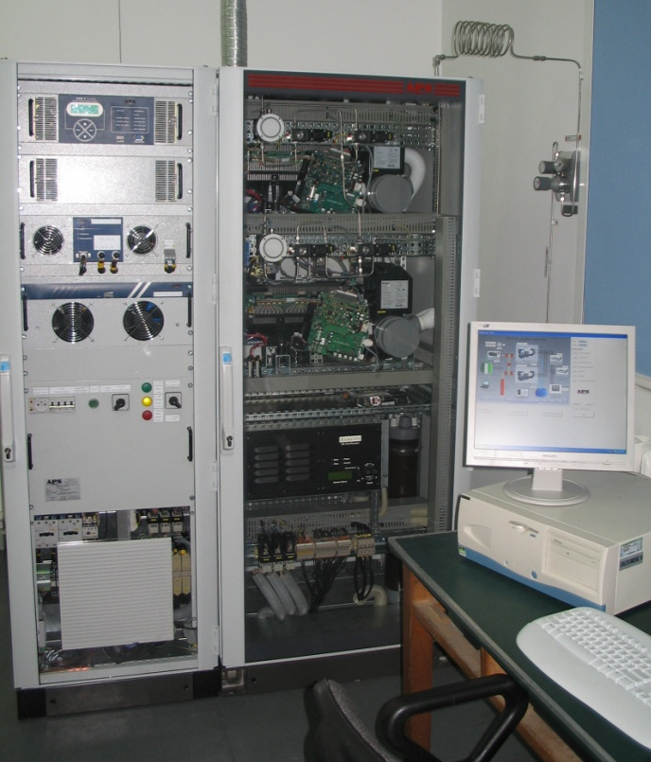
Fig. 1. View of the module

More details regarding experimental apparatus are presented in [14].
- Results
The steady state polarization curve displayed in Fig. 2 shows regions where there are either stable steady states that could exist for the same set of operating parameters (feed flow rate, temperature and load resistance). Present results are in good agreement with manufacture’s data [13].
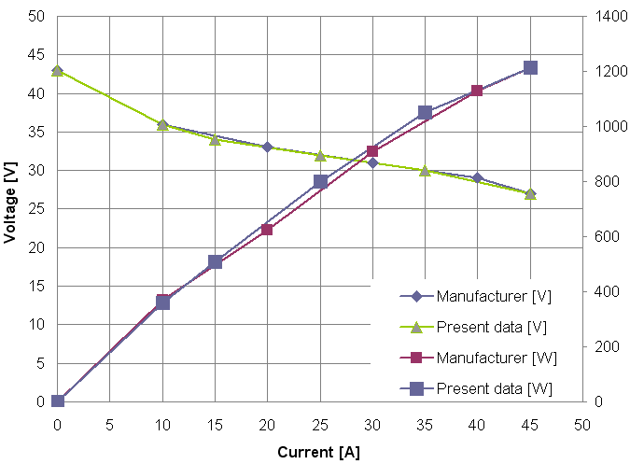

Fig. 2. Steady-state characteristics
As an example Fig. 3 displays power of the fuel cell and simultaneously air excess ratio against time for the lowest resistive load tested. For each set of resistors (load) three characteristic points can be distinguished; every about 15 seconds – point C, a drop in air excess ratio value has been observed, independent of load and air volume flow rate. For air excess ratio value below 1.9 power of the fuel cell increased considerably, nevertheless on-board control system and software for measuring and collecting data of internal states (delivered by manufacturer) switched off the system – point A in Fig. 3, and after very short time switched on the system and as a result air excess ratio reached very high value – point B in Fig. 4.

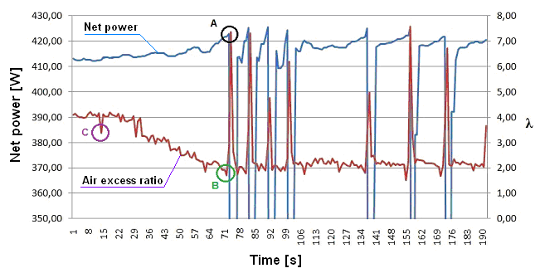
Fig. 3. Power of the fuel cell and air excess ration versus time

Figure 4 shows power of the Nexa fuel cell as a function of air excess ratio for 5 loads (current values), i.e. 35 A, 32 A, 19.5 A, 11.5 A oraz 5 A. Contrary to [15], power of the tested Nexa fuel cell slightly decreases with air excess ratio increase, about 1-1.5% with $λ_{O_{2}}$increase from 1.9 to 5.2. According to [8] dramatic drop in net power of Nexa module depends on stack current and there exists an optimal value of $λ_{O_{2}}$by which maximal net power is obtained. For instance, for stack current 30 A and 5 A, optimum air excess ratio is about 2 and 5, respectively.

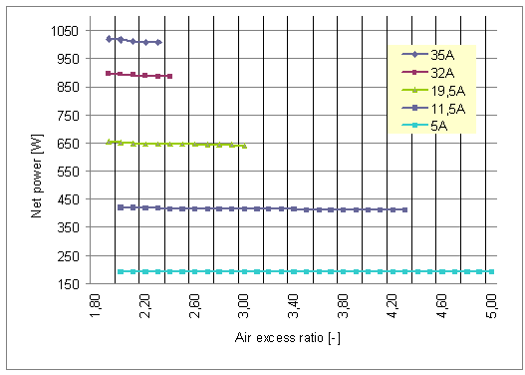
Fig. 4. Power of the fuel cell versus air excess ratio

Fig. 5 illustrates the polarization curves of a fuel cell at several operating temperatures with the range of 30°C to 65°C. These curves indicate that fuel cell performance was improved with operating temperature increase. The improvement in the fuel cell stack performance with operating temperature increase, in terms of the measured voltage, can be explained by the increase in the gas diffusivity and membrane conductivity at higher temperatures. The gas diffusivity is improved with fuel cell temperature increase, therefore, the fuel cell stack performance is improved at higher temperatures. As a result the kinetics reaction is improved [16].
Fig. 5. Effect of the operation temperature on the polarization curves

Fig. 6 displays voltage and current output as a function of stack power. Operating temperature of fuel cell was changed from 30°C to 65°C. Current output increases almost linearly with stack power reading about 38 A for power output 1015 W. Simultaneously, recorded voltage drops from 38 V to 27 V for minimum and maximum power output, respectively.
Fig. 6. Effect of operating temperature on the performance of fuel cell

Fig. 7 shows effect of operating temperature on the power of fuel cell. Electrical power decreases slightly with increase stack temperature from 1015 W for 30°C to 1004 W for 65°C.

Fig. 7. Effect of operating stack temperature on the power of fuel cell
- Summary/Conslusions
Obtained results show that power of the Nexa fuel cell slightly decreases – of about 1-1.5%, with air excess ratio increase from 1.9 to 5.2.
The polarization curves of the fuel cell showed that the fuel cell performance was improved with increase of the stack temperature. The power of the fuel cell module decreases with stack temperature increase.
References
[1] Kordesch K., Simander G.: Fuel Cells and Their Applications, VCH, Weinheim, 1996
[2] Corbo P., Migliardini F., Veneri O.: An experimental study of a PEM cell power train for urban bus application. J. Power Sources, 181 (2008) 363-370.
[3] Pei P., Chang Q., Tang T.: A quick evaluating method for automotive fuel cell lifetime. Int. J. Hydrogen Energy, 33 (2008) 3829-3836.
[4] Schmittinger W., Vahidi A.: A review of the main parameters influencing long-term performance and durability of PEM fuel cells. J. Power Sources, (180) 2008 1-14.
[5] Gruber J.K., Doll M., Bordons C.: Design and experimental validation of a constrained MPC for the air feed of a fuel cell. Control Engng Practice, 17 (2009) 874-885.
[6] Pukrushpan J.T., Stefanopoulu A.G., Peng H.: Control of fuel cell breathing. IEEE Control Systems Magazine, 24 (2004) 30-46.
[7] Gabin W.G., Dorado F., Bordons C.: Real-time implementation of a sliding controller for air supply on a PEM fuel cell. J. Process Control, 20 (2002), 325-336.
[8] Wendeker M. et al.: Adaptive airflow control of the PEM fuel cell system. SAE Technical Paper (2007) doi:10.4271/2007-01-2012
[9] Chen Q., Gao L., Dougal R.A., Quan S.: Multiple model predictive control for a hybrid proton exchange membrane fuel cell system, J. Power Sources, 191 (2) (2009) 473-482.
[10] Zhang Z., Huang X., Jiang J., Wu B.: An improved dynamic model considering effects of temperature and equivalent internal resistance for PEM fuel cell power modules, J. Power Sources, 161 (2006) 1062–1068.
[11] Xue X., Tang J., Smirnova A., England R., Sammes N.: System level lumped parameter dynamic modelling of PEM fuel cell, J. Power Sources, 133 (2004) 188–204.
[12] Beicha A., Zaamouche R.: Electrochemical model for proton exchange membrane fuel cell systems, Journal of Power Technologies 93 (1) (2013) 27–36.
[13] NexaTM Power Module User’s Manual, Ballard Power Systems, June 2003.
[14] Cieśliński J.T., Kaczmarczyk T., Dawidowicz B.: Performance of the PEM fuel cell module. Part 1. Dynamic characteristics, sent for publication in Journal of Power Technologies
[15] Węcel D.: PEMFC cooperating with PV and hydrogen generator with the use of waste heat. Systemy, technologie i urządzenia energetyczne. Tom. 1 pod red. J. Talera, Kraków 2010 (in Polish).
[16] Zhang J., Tang Y., Song C., Cheng X., Zhang J., Wnag H.: PEM fuel cells operated at 0% relative humidity in the temperature range of 23–120 °C Electrochimica Acta, 52 (2007) 5095-5101.

