Efficiency of selected methods of hydrogen removal from containment of a nuclear reactor
Tomasz Bury
Institute of Thermal Technology, Silesian University of Technology, Konarskiego 22, 44-100 Gliwice, Poland

Abstract
A large amounts of gaseous hydrogen may be released into the containment building during a severe accident in water cooled nuclear reactor. Main methods of hydrogen removal from the containment are shortly described in this paper. An in-door lumped parameter computer code HEPCAL was used to simulated these system operation. Results were next used to evaluate the efficiency of different hydrogen removal systems.

Keywords: Nuclear reactor, Containment, Hydrogen, Hydrogen removal systems,Thermal-hydraulic analysis

- Introduction
There are 434 power nuclear reactors in operation around the world and 402 units are water cooled and moderated (Boiling Water Reactors – BWR, Heavy Water Reactors – HWR and Pressurized Water Reactors – PWR) [1]. 62 of 69 reactors under construction at the moment are of the water type also.
Two main problems related to a nuclear reactor operation are the presence of large amount of highly radioactive material in the core and so-called after heat power.
The system of barriers is utilized to prevent a release of radioactive materials to the environment from a nuclear reactor's core. These barriers, in case of water reactors, are the nuclear fuel structure, fuel cladding, walls of the primary cooling circuit and the containment building. Reliability of these barriers is very high and it is very unlikely to fail them all simultaneously.
Shutting down a nuclear reactor means stopping the chain fission reaction but the heat is still produced by fission products decay reactions. This is so-called residual heat or after heat power [2]. Therefore it is very important to assure sufficient core cooling in all operating modes and during accidents too.
Gaseous hydrogen may be generated in the overheated core region. The main source of this gas in the core region is the exothermic reaction of steam with the nuclear fuel cladding (zirconium alloy). Amounts of hydrogen produced by such reaction is proportional to the mass of zirconium reacted [3]. This gas may be released into the containment building either by a break in the primary cooling circuit during a loss-of-coolant accident, or by a safety relieve valve (as in Fukushima Dai-ichi nuclear power plant [4]). Mixing of hydrogen with the air in the internal atmosphere creates flammable mixtures. The problem of hydrogen combustion and detonation is one of crucial issues for containment integrity. Taking this into account it is very important to avoid such situations and make possible removal of this gas.
Efficiency of two methods of hydrogen removal from the containment structure has been assessed based on results of simulations realized by means of the in-door computer code HEPCAL. This is the lumped parameter code for analysis of the PWR type nuclear reactor containment transient response. Real systems utilizing the described hydrogen removal methods have been simulated in the first step applying design basis accident scenarios. As the results could not be directly compared, in the second step a virtual experiment has been simulated too.
- Characteristics of hydrogen removal systems from containment building
Five methods of hydrogen removal from the containment building can be distinguished:
- intended ignition of hydrogen for its controlled combustion,
- recombination of hydrogen by catalytic devices,
- removal of oxygen by pre-inertisation,
- dilution of the atmosphere by post-accidental injection of inert gas,
- dilution of the atmosphere by increase of the containment volume.
In fact only the two first methods from this list really remove hydrogen from the containment. The last three methods decrease the hydrogen concentration in the internal atmosphere, but the amount of hydrogen in the containment is the same.
A very important issue related to prevention of the hydrogen combustion is mixing of the containment atmosphere in order to prevent high local concentrations of hydrogen. The mixing process depends on the arrangement of the constainment buliding - its division on subcompartments and connections between them as well as the dispositions of various structures and equipment. The mixing of the containment atmosphere may be a passive process occuring due to gas flows inside the containment. These flow may be induced by coolant break flow, buoyancy effects origin from density differences in various areas and buoyancy effects due to recombination of hydrogren in catalytic devices [6]. Cooling fans may also be used for the containment mixing.
The mitigation strategy choice depends on the design of the containment. Regarding this following general observations can be recorded [5]:
- pre-inertisation is applied in most of older boiling water reactors small containments as Mark I and Mark II,
- more recent BWRs with Mark III containments, multi-units CANDU, pressurised water reactors with ice condensers use igniters and sometimes PARs also,
- modern PWRs with large dry containments are equipped with catalytic recombiners.
Implementation of catalytic recombiners in existing nuclear power plants is the main tendency for hydrogen hazard mitigation in European Union and Canada for design-basis accident and beyond-design-basis accident. Passive catalytic recombiners are used for the design-basis accident in Eastern Europe and United States of America. A catalytic recombiner is passive device – no external energy is needed for its operation, and is self starting also at low temperatures and wet conditions. The recombiner consists of a vertical channel or stack equipped with a catalyst cartridge in the lower part. Such design creates so-called “chimney effect” – a gas mixture flows through the recombiner by means of natural circulation. The basis of the operation of passive autocatalytic recombiner is the exothermic reaction of hydrogen and oxygen present in the containment atmosphere taking place on catalyst surface. The catalytic cartridge contains plates or spheres coated with noble metals: palladium or platinium. The simplified diagram of a PAR is shown in Fig. 1.

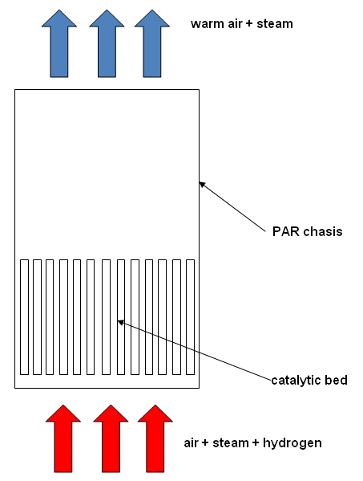
Fig. 1. Passive Autocatalytic Recombiner – scheme of construction
Pre-inertisation is characteristic feature of BWRs containments. The aim of this method is oxygen removal or dilution by injection of inert gases such as carbion dioxide or nitrogen. Combustion prevention at all possible hydrogen concentrations requires the minimum initial concentrations of carbon dioxide or steam of 60% vol. and about 75% vol. for nitrogen [7]. This method is applied in Japan, United States of America and Sweden.
Japanese BWRs utilize igniters also [5] in order to ignite a flammable mixture, and thus consume hydrogen at lower concentrations. This action leads to local temperature and pressure increase, but it is expected that the peak values of these parameters would be relatively low assuming that slow deflagration mode combustion will take place [6]. Distribution of igniters is crucial to prevent high local concentrations of hydrogren. Therefore a detailed knowledge of this gas distributions in the containment, as well as places of possible rapid steam condensation is necessary. An igniter has usually the form of a glow plug, similar to that utilized in diesel engines.
- Numerical tool
The results received here are an effect of simulations performed using the HEPCAL-AD code. This code has been worked out at the Institute of Thermal Technology of the Silesian University of Technology [8]. The code, of the lumped parameter type, is aimed to predict changes of thermodynamic parameters within containment during LOCA. The whole containment is simulated by a couple of zones (volumes), connected to each other in the given way. Usually the geometry and dimensions of a control volume correspond to the real dimensions of the specified compartment of the accident localization system. The control volumes are connected through open channels, orifices, valves, membranes or siphon closures. For each zone homogeneous conditions (perfect mixing) are assumed. Considering this one may note that the applied model is a discrete one in reference to space and time also. Its base are the energy balance equations written for each specified control volume in the given time span (time step) Δτ.
Energy streams flowing in and out of the control volume are associated primarily with heat transfer to walls and structures and intercompartment flows of media. A very important issue in modeling is taking into account operation of safety systems. Mass and energy streams resulting from operation of pumps, fans and other devices should be considered in the energy balance. These quantities as well as the initial internal energy U₁ are determined based on the values of thermodynamic parameters at the beginning of time step.
Transforming general relationship for energy balance in a control zone one obtains:
$U_{2}=({\overset{˙}{E}}_{\text{in}}−{\overset{˙}{E}}_{\text{out}})Δτ+U_{1}$, | (1)
where ${\overset{˙}{E}}_{\text{in}}$ and ${\overset{˙}{E}}_{\text{out}}$are the energy flow rates flowing into a control zone and flowing out of a control zone respectively. The right hand side components of the equation (1) are known, so the internal energy at the end of the time step can be calculated. Unknown thermodynamic parameters at the end of the time step are functions of the internal energy U₂.
Such approach allows for one dimensional analysis and determination of time dependent changes of basic thermodynamic parameters (temperature, pressure) within the containment building. It should be clearly stated that the model does not include processes taking place within the primary cooling circuit. Data considering the coolant leakage (mass flow rates and specific enthalpy) are the boundary conditions for HEPCAL code. These information are take from external programs.
The mathematical basis of the model describing changes of thermodynamic parameters consist of the equations of mass and energy balance for specified phases and equations of state [8-10]. The equations of mass and energy balance apply to the time step Δτ, however the equations of state concern to the end of each time step. All the equations are nonlinear and their form depend on the state of the specified agents in the control volume. The basic set of equations constituting the mathematical model consists of:
- equations of the energy and mass balance for each control volume,
- equations describing intercompartment flows,
- equations of state for the specified gaseous agents (air, steam, hydrogen),
- equations describing additional phenomena, e.g. heat transfer to the walls and structures, operation of safety systems.
As thermodynamic nonequilibrium between states is assumed the basic equations mentioned earlier may have different form, depending on an actual state of water and steam within the control zone. The model includes six possible cases:
- lack of water, superheated steam,
- subcooled water, superheated steam,
- subcooled water, saturated steam,
- saturated water, superheated steam,
- saturated water, saturated steam,
- lack of water, saturated steam.
Determination of unknown parameters is a gradual process. In the first step mass and energy streams are determined, eg. leak of coolant from the primary circuit, media flows through the intercompartment junctions, mass flow rate of water from the spraying system, accumulation of heat in walls and structures. Heat transfer between phases is also calculated in this step. All these quantities regard to the beginning of time step and allow for determining the internal energy of gas and liquid.
Taking this into account the amounts of media, as well as the internal energy at the end of time step are computed in the second step. The amounts of steam and water and their internal energies initially are determined neglecting the phase changes during the time step.
The values of the basic thermal parameters are determined in the third step. For calculation of these parameters from equations listed above are chosen these ones which are valid for actual state of media within the control volume. Eventually one gets a system of n nonlinear equations, which is solved using the Newton-Raphson's method. A number of equations in the system depends on current state of agents in the control zone. The calculating process is repeated in each time step for every control zone as far as the desired accuracy is achieved.
Values of remaining unknown parameters (pressures, volumes and final masses of agents) are computed in the last step from basic thermodynamic laws and geometrical relationships.
The model applied in the HEPCAL code allows to determine the thermal parameters (temperature, pressure, density) in the specified volumes and the mass flow rates as well as the energy transfer rates between the control zones. The spraying system work is taken into account as well as the heat transfer between phases and heat accumulation in the structures of the containment.
- Numerical simulations
  - Analysed systems
The main problem in chosing a system for analysis is caused by application of some methods of hydrogen removal (as preinertisation or igniters) for boiling water reactors mainly. In order to compare results of such system operatrion the analysis should be performed for similar systems. It was decided that containment structure for one selected reactor will be analysed, but with different hydrogen removal systems in subsequent simulations. The VVER-440/213 reactor has been chosen as its containement construction comprises some characteristic features for boling water reactors as well as for pressurized ones too.
Pressurized water reactors of the VVER- 440/213 type have a containment building which is connected with a bubble condenser. The bubble condenser acts as a pressure suppression system by condensation of released steam. Specific features of the VVER 440/213 containment are the subdivided rectangular building and the localization tower including the bubbler trays and air traps (Fig. 2). The containment is designed to prevent the escape of steam and fission products in any loss of coolant accident cases, including the double ended guillotine rupture of a 500 mm diameter main circulation pipe (this is the design basis accident – DBA) [11]. The design pressure of the containment is 0.25 MPa.
The accident localization system consists of the bubble condenser and the air traps. The aim of the localization system is to decrease the maximum pressure and to ensure the near atmospheric pressure after 5 to 10 min of the pipe break [12]. The localization tower contains about 1500 m³ of water distributed among 12 elevation of trays. The air volume of trays is connected to four air traps through the check valves. The steam condenses flowing to the water trays through a layer of the water. Non condensable gases and air accumulate in the gaseous space of the water trays and, after crossing the border pressure, flow to the air traps.

Fig. 2. Simplified sketch of the VVER 440/213 reactor containment (1 – reactor pressure vessel, 2 – steam generators, 3 – reactor coolant pumps, 4 – spraying system, 5 – water trays, 6 – check valves,7 – air traps)

Four variants of hydrogen removal system have been analysed for the described containment.
First variant assumes that the system under consideration is equipped with 28 passive autocatalytic recombiners of FR1-1500T type and 4 devices of FR1-750T type of the AREVA company. The nominal capacity of these PARs is equal to 160 kg of hydrogen per hour for reference conditions (absolute pressure 150 kPa, temperatue 60°C and hydrogen concentration of 4%). The PARs start their operation at the hydrogen concentration equal to 2% (volume fraction) [13].
Next two variants concern oxygen dilution methods. In the second variant it was assumed that the internal atmosphere is preinerted with nitrogen. Initial concentration of this gas is 75% by volume. Third variant assumes post accident inert gas (nitrogen) injection. The injection rate is constant during the accident and is equal to 5 kg/s. As nitrogen is the inert gas and it worsens the heat transfer conditions it was assumed the injection starts while the first hydrogen portion is released into the containment building from the primary circuit.
The last variant is the hydrogen removal system based on hydrogen igniters. This case is the most problematic due to a lack of sufficient data. According to [6] it was assessed that the analysed containment system may need about 100-120 igniters. Applying this number to the lumped parameter code HEPCAL is useless as the code operates on average values of parameters within each control zone (perfect mixing conditions). Therefore, it was assumed that instead of a large number of igniters only one “lumped” igniter is present in each control zone and it needs 15 seconds to heat up to the required temperature of ignition. The other problem is that the igniters should prevent high local concentration of hydrogen and such information are unavailable in the lumped parameter approach. Optimized arrangement of igniters means that combustion starts as soon as possible [6]. Taking this into account it was assumed that in each control zone the igniter will be activated every five minutes and it will cause burn out of 80% of hydrogen present in this zone. The first activation will take place five minutes after the first portion of hydrogen appears within the containment. In view of the above, it is expected that the results of the simulation for this case will be burdened with significant uncertainty.
  - Numerical model and boundary conditions
According to the requirements of the applied mathematical model the containment structure under consideration has been divided on nine control volumes. The nodalization scheme is shown in Fig. 3. and it is as follow: zone 1 – volume of 6370 m³ (half of the steam generator boxes); zone 2 – volume of 6370 m³ (half of the steam generator boxes); zone 3 – volume of 2000 m³ (connecting channel); zone 4 – volume of 3000 m³ (the shaft of the accident localization tower); zone 5 – volume of 2667 m³, including 500 m³ of water (water trays - 4 lower levels); zone 6 – volume of 5333 m³, including 1000 m³ of water (water trays – remaining levels); zone 7 – volume of 4200 m³ (first air trap); zone 8 – volume of 12 600 m³ (remaining air traps); zone 9 – volume of 6000 m³ (closed subcompartments connected to the steam generator boxes with open channels of constant flow cross-section area).

Fig. 3. Nodalization scheme of the VVER-440/213 containment building

In the above figure the continuous lines mean junctions by open channels of constant flow cross-section area and dashed lines mean junctions by siphon closures.

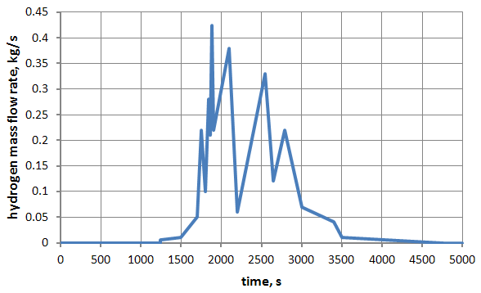
Fig. 4. Mass flow rate of hydrogen flowing into the break zone

The analyzed accident scenario is medium break loss-of-coolant accident (LOCA). The accident is initiated by a rupture of the primary circuit pipe of the effective diameter equal to 100 mm. The break takes place in the steam generator boxes (zone 1). The low and high pressure emergency coolant injection as well as the active spraying system are unavailable during the accident [14]. Hydrogen is produced in steam-zirconium reaction within the core region and it is next released into the containment via the break. Figure 4 presents the mass flow rate of hydrogen released to the break zone. It was assumed that temperature of hydrogen is constant and equal to 500°C.
  - Results of simulations
The most interesting results are the mass of hydrogen released into the containment an its concentration. The time dependend trends of these parameters have been presented in Figs. . The results concern the control zone number 1 where the rupture of the primary circuit was assumed.
The first stage of simulations have been realized without operation of the hydrogen removal system. The results are shown in Figs. 5 and 6. Taking into account a 4% flammability limit it can be seen in Fig. 6 that this limit is achieved within about 20 minutes after first portion of hydrogen appears in the steam generator boxes.

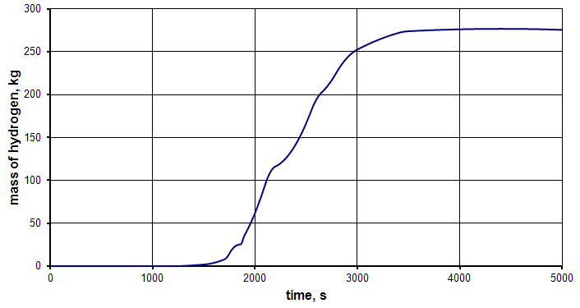
Fig. 5. Mass of hydrogen accumulated within the break zone – simulation without operation of hydrogen removal system

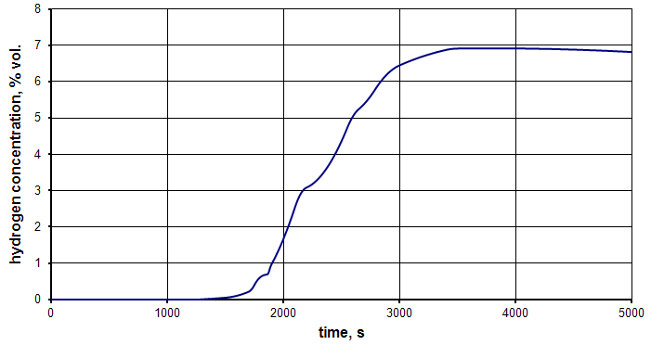
Fig. 6. Hydrogen concentration trend within the break zone – simulation without operation of hydrogen removal system

The PARs based hydrogen removal system operation has been simulated in the next step. Computations were accomplished assuming constant capacity of the catalytic devices. As mentioned before the PARs are activated after crossing the 2% hydrogen concentration limit. The hydrogen removal system operation allowes for recombining over 50 kg of this gas within the analysed time period, as shown in Fig. 7. The hydrogen flammability limit is crossed in this case too (see Fig. 8), but the concentration of hydrogen falls down below this limit within about 37 minutes.

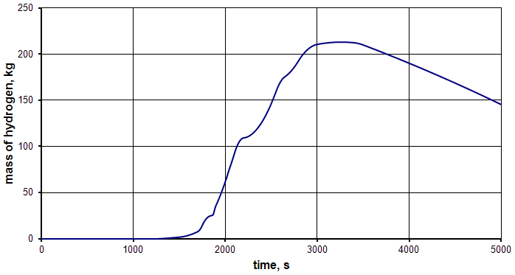
Fig. 7. Mass of hydrogen accumulated within the break zone – simulation with PARs operation

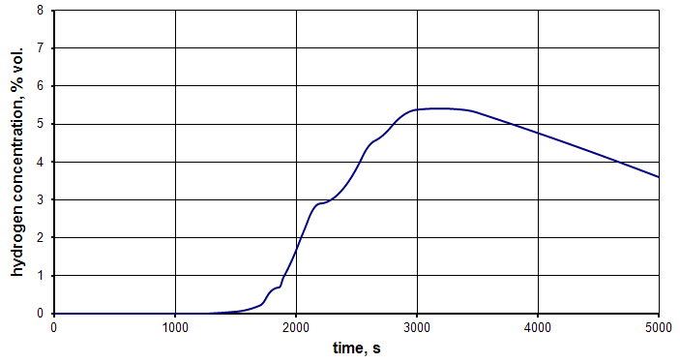
Fig. 8. Hydrogen concentration trend within the break zone – simulation with PARs operation

Third analysed case is the hydrogen removal system variant based on preinertisation of the internal atmosphere with nitrogen. The initial nitrogen concentration in the air and nitrogen mixture is 75% and this means that initial oxygen concentration is reduced to about 5,2% level. The mass of hydrogen accumulated within the break zone in this case is the same as in the first analysed scenario without hydrogen removal (see Fig. 5), as this gas is not removed from the containment.

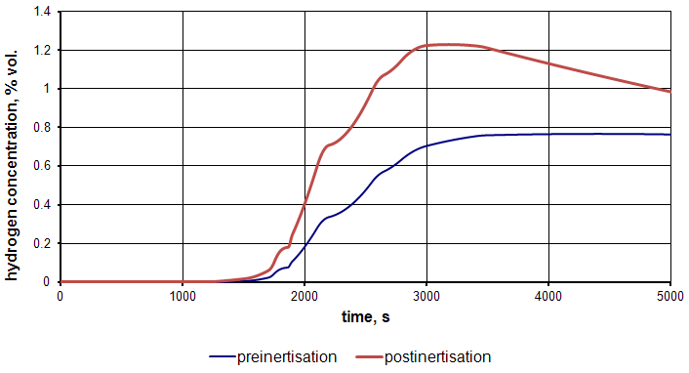
Fig. 9. Hydrogen concentration trend within the break zone – comparison of preinertisation and postinertisation cases

The hydrogen concentration trend is shown in Fig. 9 for that case and it is compared with the post accident nitrogen injection case. As it can be seen in both cases the maximum hydrogen concentration is far below the flammability limits.

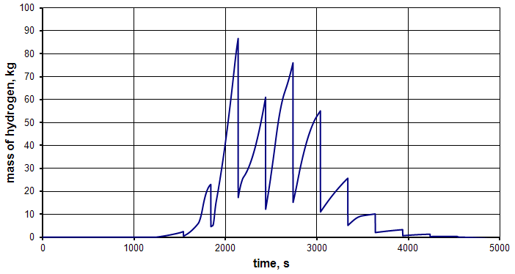
Fig. 10. Mass of hydrogen accumulated within the break zone – hydrogen igniters case

The results for the last analysed case are presented in Figs. 10 and 11. There are some simplifications in modeling combustion of hydrogen – a very simple model of reaction kinetics has been applied. Presented trends clearly show that the igniters should not be time controlled. Such a solution may lead to combustion of large amounts of hydrogen in some cases (see Fig. 10). The igniter initiated hydrogen combustion should not cause the excess pressure loads more than 30 kPa [6]. In the analysed case these loads have reached almost 180 kPa. Howeber, this could be an effect of combustion modeling – it was assumed that hydrogen is burn out immediately after ignition.

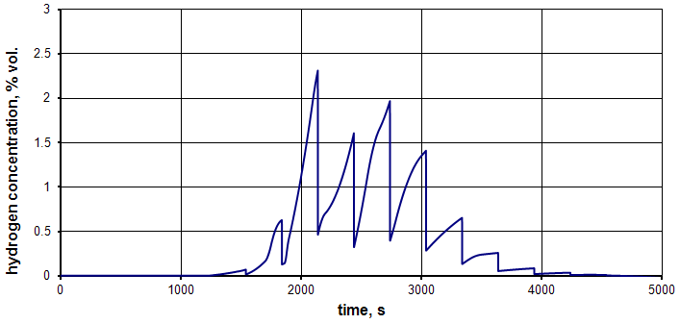
Fig. 11. Hydrogen concentration trend within the break zone – hydrogen igniters case

Results shown in Fig. 11 suggest that a self ignition of hydrogen would not take place (the 4% flammability limit was not exceeded).
- Conslusions
Simulations realized in this work have been conducted for some “artificial” systems just to make possible comparison of different methods of mitigation of hydrogen risk. Especially the inertisation methods are not practicall for the considered containment of the VVER-440/213 reactor due to a large volume of this system.
According to the results of analyses presented here it may seem that the oxygen dilution by preinertisation or postinertisation is the most efficient way for mitigating the hydrogen hazards within containments of water reactors. The hydrogen igniters seem to be a good solution also. However, these devices need an electric power supply to operate and a very detailed information on hydrogen behaviour in the containment in order to properly distribute them. Passive acutocatalytic recombiners look as the worst solution, but it should be noted here that they do not need any external supply and are self initiating devices.
Evaluating these results it should be clearly noted that the analyses have been accomplished with a lumped parameter code. Such a code applies the perfect mixing condition within a control volume. Therefore the results of simulations may be burdened with large uncertainties. It is obvious that near the break location the hydrogen concentration will cross the flammability limits much earlier than it is predicted by the code.
Crossing the flammability limits does not mean automatic hydrogen self ignition – when there is a large amounts of steam it prevents the combustion of hydrogen. On the other hand, a rapid condensation of steam may lead locally to high concentrations of hydrogen and may create detonable mixtures. In order to obtain a knowledge of local distribution of hydrogen a more detailed modeling than lumped parameter approach is necessary.
There is another problem considering the hydrogen risk also: hydrogen combustion may be caused by an electric spark or when the gas stream hits some hot surface. These are some stochastic events and it is impossible to take them into account with satisfying accuracy.
Summarizing it can be noted that the lumped parameter approach for modeling of a containment thermal-hydraulic may lead to large uncertainties in some cases. Evaluating of these uncertainties is very difficult.
Acknowledgements
This work has been financed by the National Centre for Research and Developement within the framework of the national strategic project “Technologies supporting development of safe nuclear power”.
References
[1] International Atomic Energy Agency: Power reactor information system – PRIS. Available at http://www.iaea.org/pris/ - Access on September 29 2013.
[2] Lamarsh J.R., Baratta A.J.: Introduction to Nuclear Engineering. Prentice Hall, New York 2002.
[3] De Boeck B.: Introduction to severe accidents. Especially the containment behaviour. AIB VINCOTTE NUCLEAR report AVN 97/013.
[4] International Atomic Energy Agency: Nuclear Emergency Response Headquarters – Government of Japan: Report of Japanese Government to the IAEA Ministerial Conference on Nuclear Safety. IAEA, Vienna, June 2011.
[5] Bachellerie E, Arnould F.: Generic approach for designing and implementing a passive autocatalytic recombiner PAR system in nuclear power plant containments. Nuclear Engineering and Design 275, 2002, s. 1-15.
[6] Sehgal B.R. (ed.): Nuclear safety in light water reactors. Severe accident phenomenology. 1st Edition, Elsevier Academic Press, 2012.
[7] International Atomic Energy Agency: Mitigation of hydrogen hazards in water cooled power reactors. IAEA-TECDoc 1196, Vienna, 2001.
[8] Bury T.: Analysis of thermal and flow processes within containments of water nuclear reactors during loss-of-coolant accidents. PhD thesis. Institute of Thermal Technology, Silesian University of Technology, Gliwice, 2005.
[9] Fic A., Skorek J.: Mathematical model of transient thermal and flow processes in containment of a PWR nuclear reactor. Archiwum Energetyki 1-2, 1993, s. 19-32.
[10] Skorek J., Składzień J.: Thermal analysis of the loss-of-coolant accident within the containment of the WWER-440 and WWER-1000 nuclear reactors. Computer Assisted Mechanics and Engineering Sciences 1, 3/4, 1994, s. 217-231.
[11] Bury T.: Influence of the accident localization system construction on the course of the primary circuit rupture accident in VVER 440 units. Zeszyty Naukowe Politechniki Warszawskiej, seria Konferencje z.22, t.1, 2002, s. 169-176. (in Polish)
[12] Techy Z., Lajtha G., Taubner R.: Accident loads for VVER-440/213 containment. Nuclear Engineering and Design, vol. 157, 1995, s.375-385.
[13] AREVA: AREVA passive autocatalytic recombiner. Document G-008-V1PB-2011-ENG, AREVA, Paris, 2011.
[14] Kostka P., Techy Z., Sienicki J.: Hydrogen mixing analyses for a VVER containment. Proceedings of 10th International Conference on Nuclear Engineering, Arlington, 2002, paper ICONE10-22206.

