Front Glass
PV Cell + EVA
Back Layer (Glass/Tedlar)

Fig. 1. Simple configuration of PV module
T_{air}
T_{sky}
T_{pv}
I_{g}
C_{g}
R_{pv}
R_{fg,pv-f}
R_{sky,fg}
R_{air, fg}
T_{fg}

2-a) First Layer

R_{fg,pv-fg}
R_{fg, bg/t}
R_{pv}
C_{pv}
I_{pv}-E_{pv}

T_{bg/t}
T_{fg}
T_{pv}

2-b) Second Layer
C_{g/t}
R_{air, bg/t}
R_{sky,fg}
R_{sky,bg/t}
T_{pv}
T_{sky}
T_{air}
T_{bg/t}

2-c) Third Layer

Heat capacity (Capacitor)
Heat flow (Current source)
Conductive exchange (Resistance)
Radiative exchange (Resistance)
Convective exchange (Resistance)

2-d) Legend of Electrical Circuit
Fig. 2. Equivalent electrical circuit of PV module
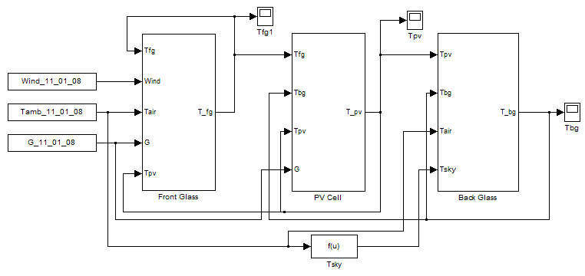

Fig. 3. Simulink block diagram of electric circuits of PV module

Fig. 4. thermal resistance of PV module

Fig. 5. Voltage sources of thermal model of PV module

Fig. 6. Current sources of thermal model of PV module

Fig. 7. DC power

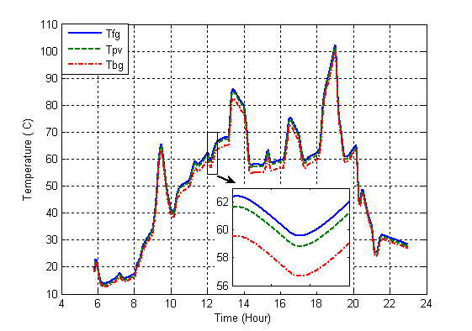

Fig. 8. PV module layers temperature in calm day (glass to glass type)

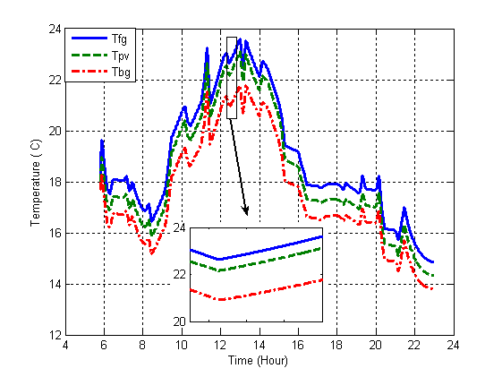

Fig. 9. PV module layers temperature in non-calm day (glass to glass type)

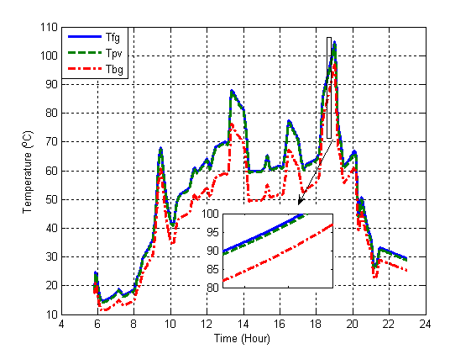

Fig. 10. PV module layers temperature in calm day (glass to tedlar type)

Fig. 11. PV module layers temperature in non-calm day (glass to tedlar type)

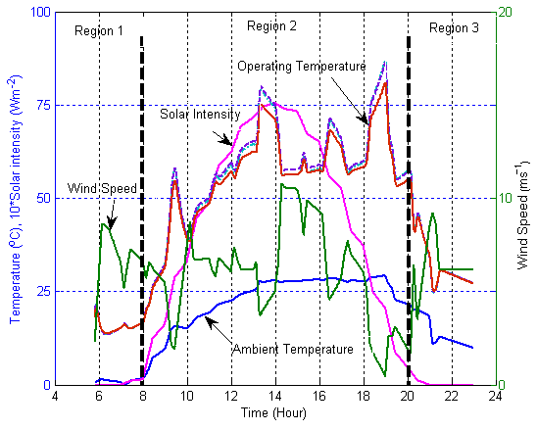

Fig. 12. PV module layers temperature

Fig. 13. Hourly variation of efficiency in calm day

Fig. 14. Hourly variation of efficiency in non-calm day

