|  |  |  |
| --- | --- | --- |
|  | 1-2 | 1-3 |
| 1-4 | 1-5 | 1-6 |

Fig. 5. SEM images of fly ash

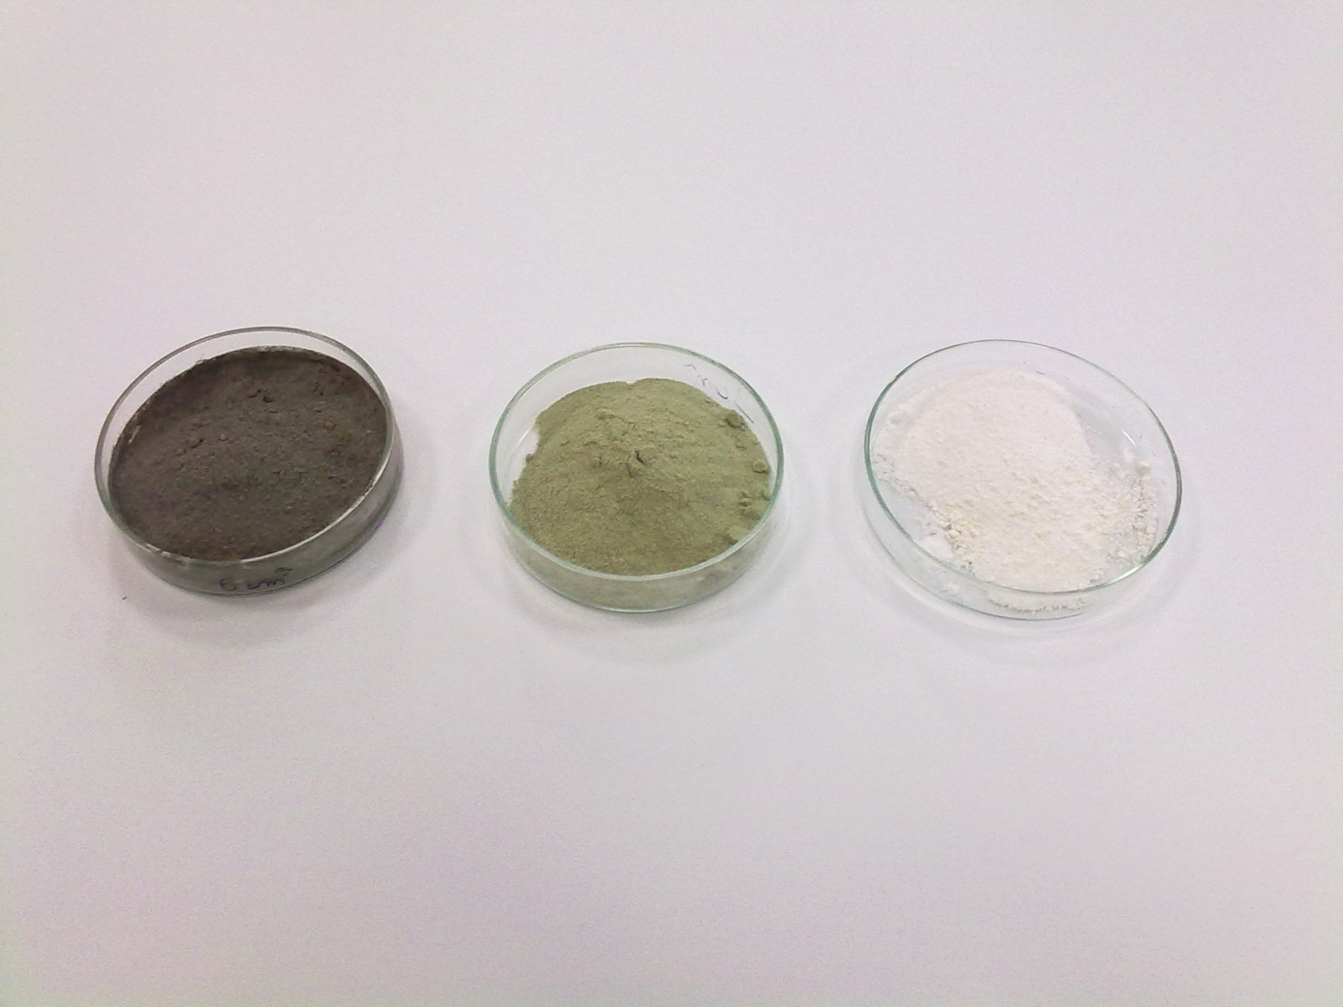

Fig. 6. Photo obtained sieve MCM-41.

|  |  |  |
| --- | --- | --- |
|  | 2-2 | 2-3 |
| 2-7 | 2-8 | 2-9 |

Fig. 9. SEM images of MCM-41