

Open Access Journal

**Journal of Power Technologies XX (X) (2011) X–X**

journal homepage: papers.itc.pw.edu.pl

An Adaptive Neuro-Fuzzy based Methodology for Harmonic Analysis of Power Transformer

Shabana Urooj1, Mohammad Amir2*, Aiman Khan3 and Mohd Tariq4

*1 Department of Electrical Engineering, College of Engineering, Princess Nourah Bint Abdulrahman University, Riyadh Saudi Arabia (On leave from Gautam Buddha University, Gr. Noida UP-201312, India).*

2Department of Electrical Engineering, Madan Mohan Malviya University of Technology (MMMUT), Gorakhpur-273010, India.

*3Department of Electrical Engineering, Indian Institute of Technology (IIT), Ropar, Punjab-140001, India.*

4Department of Electrical Engineering, ZHCET, Aligarh Muslim University, Aligarh-202002, India.

# Abstract

The interfering nature of harmonic always causes various power qualities issues, that deduct the expected transformer life as well as efficiency to an uncertain limit. The optimal analysis of the harmonic spectrum on three-phase core power transformers can limit these power quality issues. This paper designs the Adaptive Neuro-Fuzzy Inference System (ANFIS) based estimation of loses and design parameters selection using different core material in three-phase power transformers. This paper, validating different factors which deteriorating the power quality, harmonic distortion, and efficiency in power transformer. The ANFIS based analysis provides an optimal solution to resolve the harmonic reduction and gives rise to the improvement of overall efficiency. Also, this paper focuses on the comparative study of various core parameters for three-phase core transformers, that are responsible for harmonics distortions. In this paper, the ANFIS model designed for iron and ferrite core material that suitable for improving the overall efficiency of the transformer in the ANSYS Maxwell simulation. The estimation of Total Harmonic Distortion (THD) and enhancement of THD contributing to the optimal core martial. The design of three-phase power transformer and the performance evaluation of proposed methodology performed in MATLAB simulation environment.

*Keywords:* ANFIS (Adaptive Neuro Fuzzy Inference System), AI (Artificial Intelligence), T/F (Transformer), THD (Total Harmonic Distortion), E/M (Electromagnetic), ANSYS Maxwell.

# Introduction

|  |
| --- |
| ∗Corresponding author (Mohammad Amir)   * 1Email address: *shabanabilal@gmail.com* * 2*Email address*: mdamir@ieee.org* * 3Email address: *aiman.iitrpr@gmail.com* * 4Email address: *tariq.ee@zhcet.ac.in* |

Since, the global population is increasing and every industry is growing, thus the global consumption of power is getting increase day by day [1]. Thus, there is a need of more power. More power means more energy generation with more reliable power system components like power transformer. So, we cannot afford the degradation or failure of power system equipment. Transformers are available in various designs; they can be shell or core type, or applications oriented such as distribution transformer etc. Its application is based on the frequent needs and implementation purpose. Transformer plays a vital role in other power system units, which are available in the compact form whether for rectifying or low frequency application purpose. For better power transformation, it is important to have a better working environment and good working condition of the transformer, so which combines to form efficient operation. Transformers have different types of loads, that they are designed to deliver step-up or step-down voltages and currents. The transformer’s condition naturally drops during its operation because of the process of ageing [2, 3]. Ageing effect of the transformer increases due to overheating caused by overloading [4]. The design of a power transformer is a very tough task in which several engineers focuses to accomplish compatibility with the maintain the standard while minimizing the overall costs and greater efficiency [5]. The power transformer is also perilous equipment of power transmission system, which needs the fault clearance tendency in them, attending to with topmost insistence. In the transformer, if uncertainty in the fault remains unnoticed then, it may cause internal damages and will lead as severe inefficiency [6]. Fault can occur either on internal or external structures of transformers. Fault can be present in the system with a low damaging quality or can be the dangerous one. The dangerous ones can also lead to power failure, outage etc. To stop these occurrences of faults it is advised to detect it on time and clear the faults. Therefore, the overall protection of the internal and external system is a vital portion for maintaining the transformer protection [7]. The presence of harmonics and their distortions in the output of a transformer may lead to power quality issues. They are the hurdles in the power transfer, which takes place between the power systems. Conventional power system had very slightly less requirement to the transaction with harmonics because generally, loads are linear [8]. The main cause of harmonics is mainly depending on nonlinear loads [9]. Further these nonlinear loads made the power system more complex [10].

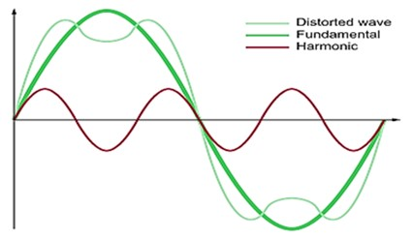

Figure 1: Harmonics and related spectrum of output waveform

The harmonics lead to power loss which increases the operational and maintenance costs. This further leads to severe heating in the transformer and fatigue of insulation [11]. Fig.1 showing the representation of harmonics spectrum. The harmonic distortions are also responsible for other problems like noise on telecommunication noise, over-temperature on electric equipment, electric stress, resonances, etc. [12]. Total Harmonic Distortion (THD) is a mathematical quantity of harmonics, that existing in an electrical signal that is termed as the ratio of the summation of powers for entire harmonic components to the power of the fundamental frequencies [13]. Mathematically THD is represented as:

$\sqrt{[\left(\frac{1}{g^{2}}\right)-1]}$ (1)

Here, g is the distortion factor which is defined as the measure for the intensity of the nonlinear distortions [14]. Mathematical relationship of THD and g is express as [15].

$\frac{\sqrt{\sum_{h=2}^{͚}{V_{h,rms}^{2}}}}{V_{1}}$ (2)

Equation 2, $V_{h,rms }$ representing the voltage harmonics (for RMS ‘h’ termed as the harmonic order) that is showing the fundamental voltages (in RMS). The effect of harmonics has the following disadvantages on the transformer [16] such as increment in core and copper losses, increase in the electromagnetic (E/M) and electrostatic interference with communication circuits, Increase in dielectric stress on insulation and generation in resonance. Nowadays new intelligence-based computational techniques have emerging for estimation of these occurrences. Such AI techniques includes fuzzy logic, artificial neural network techniques, genetic algorithms, and PSO based monitoring systems etc.

ANFIS is also one of the vital intelligence-based techniques. Adaptive neural-network-based fuzzy inference system, which is a hybridization of ANN and fuzzy logic technique. ANFIS is based on different interference systems such as Takagi–Sugeno fuzzy inference system [17]. These interference systems correspond to IF-THEN rules, which are capable of handling non-linear operations. Therefore, the ANFIS tool can work as the collective estimator. A typical Takagi-Sugeno fuzzy-based model has a basic system with the following form; When input-1 is given as ‘*x*’ and input-2 as ‘*y*’ then output ‘*z*’ is in the form of:

*Output (z) = ax + by + c* (3)

For the zero-order model, when output ‘*z*’ is constant then other functions are:

*a = b = 0* (4)

According to the desired output, the following fig.2 shows the operational framework of ANFIS for design the proposed system or a plant projected.

**ANFIS**

**Controller**

**Transformer**



**ANFIS inverse controller**

**(z)**

**ANFIS based learning algorithm**

**Inputs**

Figure 2: Framework showing ANFIS controller in a transformer plant

In 2017, J. Fan proposed a research over DGA (Dissolved Gas Analysis) which is a widespread technique to diagnosis internally faults in the power transformers. That form a hybrid-based technique, which associates with the Relevance Vector Machine (RVM). The design ANFIS technique to highlight the problem over some of the observed data. For the study of uncertain conditions, which leads to the undiagnosed using traditional techniques [18, 19]. In this research, the author has done the experiments and find out the results for demonstrating the hybrid RVM based ANFIS technique that accomplished the high accurateness percentage up to 89-94% [20]. Transformer life estimation and their breakdown diagnostics are always significant problems for the various power utilities. Similarly, J. Fan [21] presented research work on the ANFIS designed model of the power transformer for the loss of life, which is based on hourly based estimation. Here the research took the standard parameters like ambient temperature with their load level as the key components of degradation for power transformer. In 2018, S. Forouhari [22] presented a new ANFIS based decision prototype to estimation the overall life of mineral-oil-filled power transformers. Here, the authors introduced an integrated asset supervision prototype based on some analytical pointers. In early 2018, J. Kim [23] has mathematically derived the relationship between source impedance and harmonic cancellation This research is based on the performance of shunt phase shift transformer in which effect of line conductor on the cancellation was observed.

In 2019, J. Feng [24] was proposed the current analysis method to suppress harmonics in the SMES (Superconducting Magnetic Energy Storage) system. This research has been validated the theoretical analysis of the simulation and experimental verification.

This manuscript consists of six sections: Section I consists of an introduction to the problem formulation and their possible solutions, Section II; consists of the concepts and technical approach for optimal parameters selection for system design. Next section, Section III consists of the optimization parameters and system description. Further Section IV for modelling and Simulation. Section V for calculations and results analysis using ANFIS controller. The last section consists of the conclusions and future scope of the proposed ANFIS based methodology.

1. **Optimal Parameters Selection for System Design**

There are four stages involved in the designing of proposed ANFIS model, which are as following:

*2.1. Data collection and normalization stage*

In this stage, data is collected and accumulated so as for the generation of input values to the designed model with some specific parameters. The best combination presented for the inputs parameters that are as following:

1. Three phase input voltage to the transformer.
2. Induced rms (root mean square) voltage.
3. Change in winding resistance.
4. Core losses.

*2.2. Training stage of ANFIS based proposed model*

The training data sets is implemented for designing of the proposed ANFIS based model with a defined combination of the membership function. Firstly, the selection of a membership function, and the system has trained accordingly to the set of training data. Then the model is trained for finding best combinations of the input parameters.

*2.3. Error evaluation of proposed methodology*

With the use of testing data sets to the model through some training for the calculation of the error evaluation in the proposed model. Error evaluation based on the criteria from which ANFIS proposed model is tested accordingly. Which is Mean Squared Error (MSE) that is defined as the Mean squared error that finding out the average of all possible error’s square. So that means the average of the squared difference between the estimated values and what is estimated that is error [24]. The average errors of testing or training gives an idea for the average generated error during training and testing periods in the proposed model.

*2.4. Harmonic analysis and their validation*

System validation provides the concept for degree of preciseness using measured value that is based on the practical results during training and testing of the proposed model. Following parameters are taken accounts for the overall accuracy of the system:

*2.4.1. RMS value of induced voltage:* Here, the values of induced voltages have been taken for Root Mean Square (RMS) analysis and further in account for the calculation of distortion factor (*g*) which is termed as:

*g = $\frac{RMS value of induced voltage}{RMS \left(AC\right)values of induced voltage}$*  (5)

*2.4.2. THD estimation:* Estimated of Total Harmonic Distortion (THD) in the proposed ANFIS model for the transformer designs. In this research paper, the transformer model is designed with specified parameters from which THD have been found mathematically values and then compared with the results of the ANFIS Controller [25, 26].

**3. Description of 3-Phase Transformer Model**

The proposed system presented in this paper contains of a three-phase transformer with some defined parameters and employed this design system using ANFIS technique. Here is the modeling of proposed transformer based on the design parameters referred in fig.3. Design analysis of proposed three-phase transformer performed in the ANSYS (Analysis Systems Simulation) environment.

Figure 3: Transformer designed model in ANSYS toolbox

Table 1: Specification of transformer design at different case study

|  |  |  |  |  |
| --- | --- | --- | --- | --- |
| **S. No** | **Comparative analysis on different configuration of transformers** | | | |
| ***3 Phase input voltage*** | ***Core***  ***material*** | ***Linear B-H curve*** | ***Transformer***  ***designs*** |
| 1  2  3  4  5 | 20KV  20KV  20KV  11KV  11KV | iron  ferrite  iron  iron  ferrite | yes  yes  nonlinear  yes  yes | Trf#1  Trf#2  Trf#3  Trf#4  Trf#5 |

Table.1 showing the comparative analysis for different rating transformers. The description base parameters and their specification for testing of proposed model designs.

* **Transformers (Trf#):** There are different types of designed transformer models based on specific ratings, that are implementing in the ANSYS Software. They have been particularly designed for the harmonic analysis.
* **Core material used:** The materials used for the design of core transformer. Iron and ferrite materials can be employed, specifications of materials referred in table.2.

Figure 4: Total loss by Iron material (refer in table 2) using ANSYS toolbox

Table 2: Different parameters that depend on the overall performance

|  |  |  |  |  |  |
| --- | --- | --- | --- | --- | --- |
| Core  material | Relative  permeability | Young’s modulus  (N/m2) | Poisson’s  ratio | Bulk conductivity  (Siemens/m) | Mass density  (w/kg) |
| Iron  Ferrite | 4000  1000 | 1.95×1011  1.19×1011 | 0.28  0.0 | 1.03×1011  0.01 | 7870  4600 |

Total losses of different core materials directly affect the efficiency of the transformer. Efficiency can be estimate by the total loss predication. Fig.4 showing the total losses associated with iron core material in ANSYS toolbox. In proposed model, Iron core material employed because of its appropriate distribution for convergence values with high magnetic field density.

1. **ANFIS Modelling and Simulation**

The proposed ANFIS system is sort of hybrid-based learning rule having both combination of ANN and fuzzy logic controller for computational as well as logical analysis. After the selection of membership functions, training and testing of the functions will be perform. If the results are satisfactory then it goes for selection of membership functions type otherwise again it reselects the functions. Then again training and testing will be proceeding. The whole loop process goes on until the satisfactory values are obtain and after that, it compares with the satisfactory ANFIS model parameters. The structure of ANFIS consists of different node, that nodes are the one in which some or all may be adaptive.

The adaptive quality contributes the excellence controlling to output of the node. ANFIS being dependent of output parameters. Based on specified constraints of different nodes while for other nodes are fixed which means that the output of these nodes are depends on the output of preceding layer. Additional directional links are used to link the nodes in various layers, by providing a way for the flow of signal without any allocation with different weight functions based on desired output.

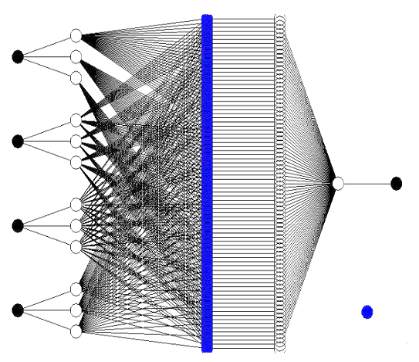

**INPUT**

**INPUT MF**

**RULE**

**OUTPUT MF**

**OUTPUT**

**3ф input**

**voltage**

**(KV)**

**Induced**

**RMS** **voltage**

**(KV)**

**Core losses**

**(KW)**

**Change in**

**resistance (mΩ)**



**Logical Operations**

**AND**

Figure 5: Simulation of proposed ANFIS based model

There are 5 layers in the ANFIS model of the proposed architecture. The layers are represented as adaptive or fixed nodes layers which are interlinked or linked through the directional links. Refer in fig.5 the first layer comprises with four inputs nodes $x_{1},x_{2},x_{3 }and x_{4}.$ Where, each node is representation of fuzzy logic sets. The response of nodes for the input of next layers, which is the belongingness degree of the input given to the fuzzy set.



Figure 6: Membership functions of FLC system for inputs

The layer 2 consists of input membership functions as $w_{11},w_{12 }$ and so on until $w_{43}$; which represents the degree of membership as an extension of valuation referred in fig.6. Layer 3 represents the rule-based layer in which input is given in a rule-defined manner. Layer 4 contains the output membership functions and layer 5 consists of the desired output. In this model. Sugeno type ANFIS model. The number of inputs is 4, and outputs are 1, while total rules base is 81, on the other hand “And Method” is taking as 'prod' and “Or Method” is taking as 'probor', and defuzzification method is taking as 'wtaver'. Our ANFIS techniques identifying each harmonic related to the fundamental frequency. There are certain physical parameters which are directly impact of harmonic spectrum such as type of core materials employed, permeabilities. etc. The ANFIS implementation and description of a different functional block for the proposed methodology are as follows.



Figure 7: Flowchart of proposed hybrid neuro fuzzy based ANFIS model

From the figure.7 the following conclusions can be made. For calculation of THD in different designs of transformers using two criteria of inputs, that have been taken in account that are:

*4.1. Evolution of harmonic rate:* It consists of the factors which effect the harmonic calculations in the transformer referred to the table.3 [27].

*4.2. Factors depending on the harmonics:* There are several factors which gets affected by the harmonic generation in the transformer:

* Data interpretations analyzed followed by the selection and correlating input variable parameters.
* Normalization of raw data sets are done through training and testing of the sets.

In above criteria’s, requirement of fuzzy surface view can be checked [28]. If it meets the desired requirements, then it goes further otherwise it again normalize raw datasets again and repeat the steps. Then, it calculates percentage of error evolved and the process will be completed.

**5. Results and Discussion**

The tabulated forms of induced voltage based on different instants which are as following in figure 8(a) to 8(e). While figures.9 contains the output waveforms of the three phase transformers. Where, x axis showing time (in ms) and y axis showing the Induce voltage (in kV) using ANFYS model.

|  |
| --- |
| Figure 8 (a): Transformer (Trf#1) voltage parameters in ANFYS toolbox |
| Figure 8 (b): for Trf#2 |
| Figure 8 (c): for Trf#3 |
| Figure 8 (d): for Trf#4 |
| Figure 8 (e): for Trf#5 |

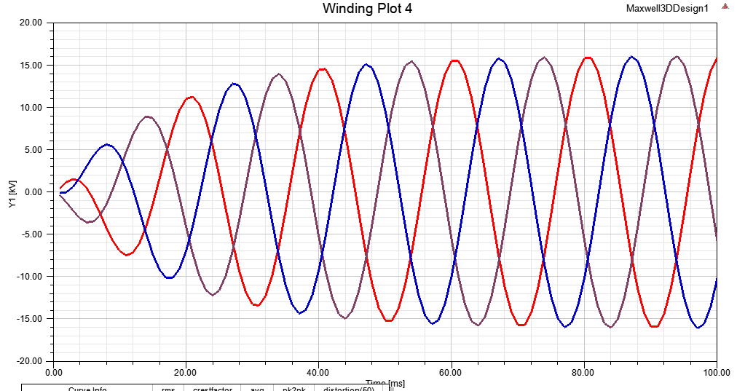

Figure 9 (a): Output induced voltage of Fig.8 (a) for Trf#1

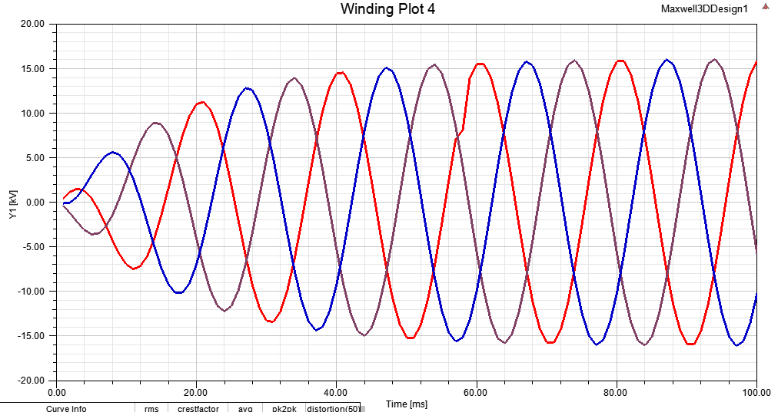

Figure 9 (b): for Trf#2



Figure 9 (c): for Trf#3

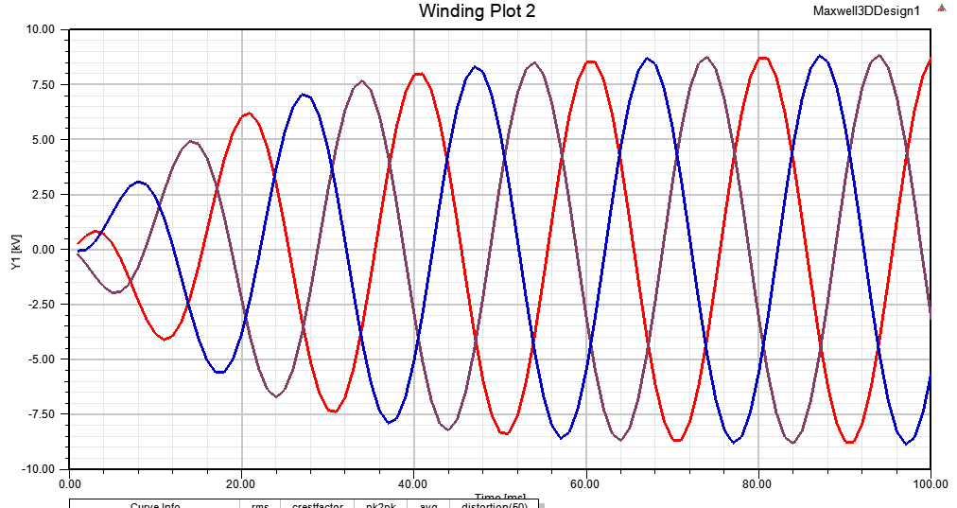

Figure 9 (d): for Trf#4



Figure 9 (e): for Trf#5

From the above-mentioned fig.9 THD has been calculated mathematically which is depicted in the following table.3. Estimated THD range within 5%, which is successfully lying in between the IEEE standard. The proposed ANFIS based approach successfully monitoring the higher component of harmonics in real time. The proposed technique efficiently measured the harmonics corresponding to induced voltages in different windings of transformer. The IEC based harmonic standard TR-(61000-3-4:1998) [29, 30] provides the novel protection scheme for transformer under various conditions.

Table 3: Comparative harmonic analysis of different transformers using Sugeno-type ANFIS model using different materials

|  |  |  |  |  |  |  |  |
| --- | --- | --- | --- | --- | --- | --- | --- |
| Transformers at different instants | Material  used | No load losses prediction  (KW) | Permeability of material  (iron/ferrite) | RMS value of induced voltage (KV) | Estimated no load % efficiency (based on running time) | Distortion factor  (g) | THD  (in %) |
| Trf#1 | iron | 46.3761 | 4000 | 9.8983 | 84.56 | 0.9993 | 3.74-3.88 |
| Trf#2 | ferrite | 46.3427 | 1000 | 9.8983 | 84.89 | 0.9993 | 3.73-3.86 |
| Trf#3 | iron | - | Nonlinear B-H curve | 9.8883 | 87.11 | 0.9992 | 2.88-3.00 |
| Trf#4 | iron | 5.4441 | 4000 | 5.4441 | 84.55 | 0.9993 | 3.74-3.88 |
| Trf#5 | ferrite | 5.4423 | 1000 | 5.4440 | 83.97 | 0.9976 | 3.67-3.70 |

In Table.3, the comparable analytical observations verified the usage of ANFIS parameters provides the better way of understanding for harmonic analysis of a three-phase transformer for different instants.

Table 4: Performance evolution of proposed ANFIS based methodology

|  |  |  |
| --- | --- | --- |
| **Parameters** | **Training** | **Testing** |
| Mean Squared Error (MSE) | 88.57 | 89.56 |
| Average Testing/Training Error (ATE) | 0.567 | 0.709 |
| Accuracy of prediction based on practical result (In %) | 88.7% | 76.44% |

The following fig.10 shows the adaptive neuro fuzzy designer model using MATLAB simulation. The proposed system for the evolution of testing error, which is 0.079094. From ANFIS model the prediction and evolution of error was better approach for the harmonic distortion’s analysis. Therefore, various component of transformer can be tested accordingly and ANFIS model can be designed for desired rating of transformers.

Figure 10: Result of neuro fuzzy designer tool in MATLAB simulation

Estimated THD range is 3-4%, which is successfully lying in between the IEEE standard for better efficiency. The highest efficiency received at trf#3 instants which is 87.11% with different loading conditions. On the other hand, at instants trf#3, THD is also reduced shown in fig.11. Therefore, for non-linear load applications the proposed core materials practically employed for 11KV desired output voltage of proposed power transformer.

Figure 11: Analysis of efficiency Vs. THD using iron core material [for Trf#(1,3,4) instant] and ferrite core material [for Trf#(2,5) instant]

# Conclusions

In this paper, the ANFIS error prediction system provided an approach for real time health monitoring of power transformer. ANN based training of the proposed model employed for different material of the power transformer. While fuzzy system is employed for the design of different ratings power transformer at various instants. Error evolution of proposed methodology is shown in tabular form (table 4) that gives a better criterion for the selection of input parameters. This research work gives an idea way for the real-time utilization of both the software’s MATLAB as well as ANSYS Maxwell design toolbox in proposed methodology. Design and simulation provided optimal approach for choosing the required parameters. For the better selection criteria of three phase transformer, the prediction of power transformer’s expected life can also be considered for better results using other AI techniques. Novel techniques such as finite element analysis can be implemented to realize every small or micro-level effect of any parameters, which directly affects the transformer efficiency.

**References**

1. C. Suppitaksakul, V. Saelee, Application of Artificial Neural Networks for electrical losses estimation in three-phase transformer, in: 6th International Conference on Electrical Engineering/Electronics, Computer, Telecommunications and Information Technology, 2009, pp. 248–251.
2. M. A. Rahman, B. Jeyasurya, A state-of-the-art review of transformer protection algorithms, IEEE Transactions on Power Delivery 3 (2) (1988) 534–544.
3. P. Rahman, D. Karunika, H. Suwarno, G. Harry, Transformer Paper Expected Life Estimation Using ANFIS Based on Oil Characteristics and Dissolved Gases (Case Study: Indonesian Transformers). Energies (2017).
4. R. Singh, A. Singh, Aging of distribution transformers due to harmonics, in: Proceedings of 14th International Conference on Harmonics and Quality of Power - ICHQP 2010, pp. 1–8.
5. D. Phaengkieo, S. Ruangsinchaiwanich, Design optimization of electrical transformer using artificial intelligence techniques, in: 18th International Conference on Electrical Machines and Systems (ICEMS), 2015, pp. 1381–1385.
6. S. Urooj, T. Singh, M. Amir, M. Tariq, Optimal Design of Power Transformer with Advance Core Material using ANSYS Technique, European Journal of Electrical Engineering and Computer Science 4 (5) (2020).
7. H. Mohammadpour, R. Dashti, Localization of short circuit faults in transformers using harmonic analysis and pattern recognition, International Conference on Advanced Power System Automation and Protection 2 (2011) 1412–1417.
8. T. Turker, N. Yorukeren, M. Sengul, B. Alboyaci, An artificial neural-net based method for predicting distribution transformer’s total harmonic distortions, in: IEEE 2nd International Power and Energy Conference, 2008, pp. 1194–1197.
9. H. Amadi, A Critical Review of Harmonics and Mitigation Techniques in Power Systems 5 (1). (2019).
10. J. R. Johnson, Managing harmonics and resonance with active harmonic filters in an offshore ring main oil field, in: 13th International Conference on Harmonics and Quality of Power, 2008, pp. 1–8.
11. M. Digalovski, K. Najdenkoski, G. Rafajlovski, Impact of current high order harmonic to core losses of three-phase distribution transformer, Zagreb, (2013) 1531-1535.
12. V. A. Ferreira, M. D. Teixeira, The influence of harmonic voltage distortion on power transformer equivalent circuit and losses, in: Simposio Brasileiro de Sistemas Eletricos (SBSE), 2018, pp. 1–6.
13. S. B. Sadati, A. Tahani, B. Darvishi, M. Dargahi, H. Yousefi, Comparison of distribution transformer losses and capacity under linear and harmonic loads, in: IEEE 2nd International Power and Energy Conference, 2008, pp. 1265–1269.
14. H. A. Kazem Harmonic Mitigation Techniques Applied to Power Distribution Networks, Advances in Power Electronics 2013 (2013) 1–10.
15. M. A. Awadallah, T. Xu, B. Venkatesh, B. N. Singh, On the Effects of Solar Panels newline on Distribution Transformers, IEEE Transactions on Power Delivery 31 (3) (2016) 1176–1185.
16. C. Platero, Testing of non-toroidal shape primary pass-through current transformer for electrical machine monitoring and protection, IEEE International Conference on Industrial Technology (ICIT) (2018).
17. A. Al-Hmouz, J. Shen, R. Al-Hmouz, J. Yan, Modeling and Simulation of an Adaptive Neuro-Fuzzy Inference System (ANFIS) for Mobile Learning, IEEE Transactions on Learning Technologies 5 (3) (2012) 226–237.
18. M. Amir, Zaheeruddin, ANN Based Approach for the Estimation and Enhancement of Power Trans- fer Capability, in: 2019 International Conference on Power Electronics, Control and Automation (ICPECA), 2019, pp. 1–6.
19. S, R. Subbanna, M. Suryakalavarthi, Performance analysis of artificial intelligence techniques to control the saturation level in the magnetic core of a welding transformer, in: 2016 International Conference on Electrical, Electronics, and Optimization Techniques (ICEEOT), 2016, pp. 3378–3384.
20. M. Şahin, R. Erol, A Comparative Study of Neural Networks and ANFIS for Forecasting Atten- dance Rate of Soccer Games, Mathematical and Computational Applications 22 (4) (2017) 43–43.
21. J. Fan, F. Wang, Q. Sun, F. Bin, F. Liang, X. Xiao, Hybrid RVM–ANFIS algorithm for transformer fault diagnosis, IET Generation, Transmission & Distribution 11 (14) (2017) 3637–3643.
22. S. Forouhari, A. Abu-Siada, Application of adaptive neuro fuzzy inference system to support power transformer life estimation and asset management decision, IEEE Transactions on Dielectrics and Electrical Insulation 25 (3) (2018) 845–852.
23. J. Kim, J. Lai, X. Liu, Analysis of Harmonic Cancellation Performance of a Shunt Phase-Shift Trans- former Rectifier, in: 2018 IEEE 4th Southern Power Electronics Conference (SPEC), 2018.
24. L. P. S. Raharja, O. A. Q., Z. Arief, N. A. Windarko, Reduction of Total Harmonic Distortion (THD) on Multilevel Inverter with Modified PWM using Genetic Algorithm, EMITTER International Journal of Engineering Technology 5 (1) (2017) 91–118.
25. M. Amir, S. K. Srivastava, Analysis of Harmonic Distortion in PV-Wind-Battery Based Hybrid Renewable Energy System for Microgrid Development, in: M. S., S. Y., T. A. (Eds.), Applications of Computing, Automation and Wireless Systems in Electrical Engineering, Vol. 553, Springer, (2019).
26. M. Amir, S. K. Srivastava, Analysis of MPPT Based Grid Connected Hybrid Renewable Energy System with Battery Backup, in: 2018 International Conference on Computing, Power and Communication Technologies (GUCON), 2018, pp. 903–907.
27. D. K. Sambariya, R. Prasad, Selection of Membership Functions Based on Fuzzy Rules to Design an Efficient Power System Stabilizer, International Journal of Fuzzy Systems 19 (3) (2017) 813–828.
28. M. J. Er, Y. L. Sun, Hybrid fuzzy proportional-integral plus conventional derivative control of linear and nonlinear systems, IEEE Transactions on Industrial Electronics 48 (6) (2001) 1109–1117.
29. J. Faiz, M. Ghazizadeh, H. Oraee, Derating of transformers under non-linear load current and non- sinusoidal voltage – an overview, IET Electric Power Applications 9 (7) (2015) 486–495.
30. A. H. Chowdhury, W. M. Grady, E. F. Fuchs, An investigation of the harmonic characteristics of trans- former excitation current under nonsinusoidal supply voltage, IEEE Transactions on Power Delivery 14 (2) (1999) 450–458.