﻿Modelling of Dry-Low Emission Gas Turbine Fuel System using First Principle Data-Driven Method
Madiah Omar*, Rosdiazli Ibrahim, M. Faris Abdullah, Haizad Tarik
﻿Department of Electrical \& Electronic Engineering, ﻿Universiti Teknologi PETRONAS, ﻿32610 Bandar Seri Iskandar, ﻿Perak, Malaysia

Abstract
﻿Dry-Low Emission (DLE) gas turbine has gained high interest due to the low CO₂ and NO_{x} emission during energy production. However, the technology is susceptible to frequent trips due to the tight control of the air-to-fuel ratio. Therefore, it is crucial to propose an accurate dynamic model to investigate the operation of DLE gas turbine. Major DLE distinction from conventional is the introduction of a pilot valve into the readily main gas fuel valve in the fuel system. Thus, this paper proposed the development of DLE gas turbine fuel system into widely used Rowen's model using First Principle Data-Driven (FPDD) method. One-month actual data were collected, and the valves model structure was predetermined before generated in system identification in MATLAB. The validated models were integrated into Rowen's model according to the actual setup of the DLE gas turbine fuel system. The simulation output; pilot and main gas fuel valves, gas fuel flow and average temperature signals were compared with the actual signal and evaluated using MAE and RMSE. First-order transfer function is selected for both valves due to the simplicity and the accuracy of the estimation. The integration of the valves into Rowen’s model produces a high accuracy of DLE gas turbine model representation for future utilization in fault identification and prediction study.

Keywords: ﻿dry-low emission, gas turbine, Rowen's model, first principle data-driven, fuel valve, first-order transfer function.

- Introduction
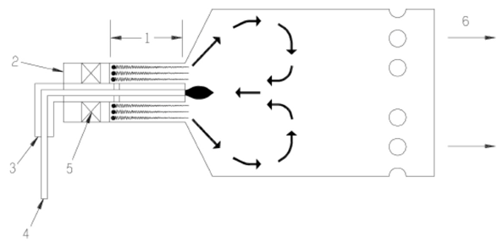
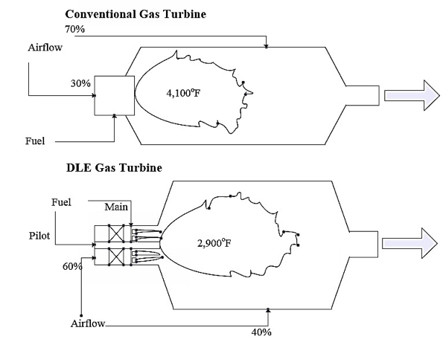
﻿Gas turbine is widely used as a prime mover in power generation due to its reliability, availability, easy operating and smooth-running during operation. The working principles generally involved with the combustion of compressed air and natural gas for thrust formation to move a connecting shaft. However, the combustion produces greenhouse gases such as COx and NOx to the atmosphere which surpass the allowable emission rate set by the authority [1, 2]. Thus, Dry-Low Emission (DLE) gas turbine is introduced as an environmentally friendly solution to overcome the aforementioned challenges [3]. DLE combustion technology operates a clean operation based on Lean Pre-mixed (LPM) as illustrated in Figure 1 to ensure COx and NOx formation reduction [4].﻿ LPM technology diffuses high content of atmospheric nitrogen before it is delivered to the combustor [5] to prevent "local hotspot" within the chamber. The appropriate stable combustion temperature is achieved by maintaining fuel management through a pilot gas fuel valve and by varying the amount of air delivered to the combustion [6]. Therefore, this type of turbine has gained high popularity in the industry to comply with the authority's emission requirement of a power plant [7]. However, the rigorous control of DLE gas turbine especially in maintaining the specific air-to-fuel ratio leads to frequent gas turbine trips [8]. This normally happened during increased load demands, high ambient temperature, sudden mechanical failures and others. ﻿Furthermore, there are limited studies in building a dynamic model for the turbine to investigate this phenomenon. Hence, a model that reflects the actual behavior of the DLE gas turbine more accurately is needed to ascertain the dynamic stability of the system.
Figure 1: ﻿Lean Premix combustion with Premixing Zone in 1, Air Inlet in 2, Main Fuel in 3, Pilot Fuel in 4, Swirler in 5 and Combustion Inlet Temperature in 6.
Figure 2: ﻿DLE and conventional gas turbine comparison.
﻿There are numerous gas turbine models in dynamic studies such as; Rowen's model [9], physical model [10-16], IEEE model [17], GAST model [13], WECC/GG0V1 model [18], aero-derivative model [19], CIGRE model and frequency-dependent model. Apart from that, black-box model also proposed in [20]. However, it has limitations in the operation representation as it neglects the understanding of the relationship of the variable. Among the listed models, Rowen's model is widely utilized due to its ability to imitating an actual gas turbine operation from the operating curves function derivation [21, 22]. Thus, the utilization of Rowen's model for DLE representation has been studied in [23]. Nevertheless, a major component of DLE, which is the pilot gas fuel valve has not been introduced to the proposed model. The valve introduction in DLE turbine plays a major role as shown in Figure 2.
﻿Major design of DLE gas turbine is the addition of a pilot gas fuel valve to the available main gas fuel valve from the conventional model [24]. The introduction aims to aid LPM combustion to produce a uniform temperature in the chamber. The bigger size of the DLE combustion chamber also observed due to the space utilization for the pilot gas fuel valve integration. Hence, modelling of pilot gas fuel valve for DLE gas turbine representation is required in this study.
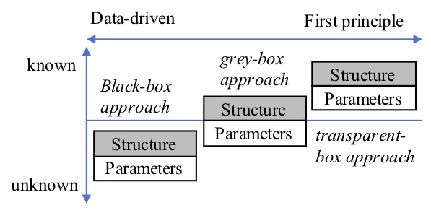
Technical system modelling is illustrated in Figure 3 .
Figure 3: ﻿First Principle and Data Driven approach comparison.
The first initial phase is the collection of available knowledge. The information will determine the final type of model, the accuracy requirement and complexity of the model [25]. According to the availability of the priori knowledge, it is either First Principle (FP), Data-driven (DD) or combination of both methods can be applied to build the model. ﻿FP model utilizes an understanding of underlying physic to develop its mathematical representation in determining the structure and parameters of the system. FP model advantage is the depth understanding of the system behavior, but expensive in development since an expert in the field is required. Moreover, FP models are regularly adjusted using a trial-and-error approach to fit a model to the data, which can result in a non-convex optimization problem [26]. In the DD model, it adopts a system test data to derive the mathematical representation [27]. From this approach, an accurate model can be formed due to the actual data utilization for the system. Nonetheless, the DD model is at a disadvantage in handling multiple data sets to cover the system operation. The last method which is First Principle Data-Driven (FPDD) approach is an exemplary tool to cover both systems understanding and accuracy. With a known structure, computation time to estimate the parameter will be reduced and a high accuracy model can be obtained.
In this paper, a DLE gas fuel system is proposed, which considers the FPDD method to represent the turbine operational dynamics. The remaining part of the paper structured as follows; section Methodology explains the gas fuel system development, which consists of pilot and main gas fuel valves. In Results and Discussion section, the pilot and main gas fuel valve models are proposed and integrated into Rowen's model according to the actual DLE gas turbine setup. Finally, fuel system integration is concluded in Conclusion section.
- Methodology
﻿This study utilized 4.2MW single shaft DLE gas turbine with a 12-stage axial compressor at Universiti Teknologi PETRONAS, Malaysia as a case study. The gas turbine is installed as a cogeneration unit to produce electricity and chilled water for academic and operational usage. The gas fuel valve system for DLE gas turbine model development flowchart can be depicted as in Figure 4.
﻿The experimental work starts with the data collection and preprocessing. Table 1 specifies as the ideal values during the design stage. It can be obtained from the catalogue of the gas turbine model.
Table 1: Typical operating data of DLE gas turbine.
Nominal Parameter (n) | Symbol | Unit | Values
Gross electrical  output | P_{G(n)} | MW | 5.67
Nominal frequency | F | Hz | 50
Turbine speed | RPM | RPM | 1500
Exhaust  mass flow | M_{(n)} | kg/s | 21.77
Exhaust  gas temperature | T_{R} | °C | 510
Pressure ratio | P_{R} | None | 11.11

Customarily, the nominal values will be diverged when the turbine installed at a different ambient condition. The typical operating data in Table 2 summarized the typical operating data from the power plant.
Table 2: ﻿Typical operating data of DLE gas turbine.
Operating Parameter (OC) | Symbol | Unit | Value
Output power | P_{G} | MW | 4.4
Turbine inlet temperature | T_{3(OC)} | °C | 1000
Exhaust gas temperature | T_{R(OC)} | °C | 532
Ambient temperature | T_{1(OC}) | °C | 27.3
Exhaust mass flow | m_{n(OC)} | kg/s | 438.1
Fuel | Gas
Fuel flow | m_{f(OC)} | kg/s | 0.377
Lower heating  Value of fuel | H | kJ/kg | 48930

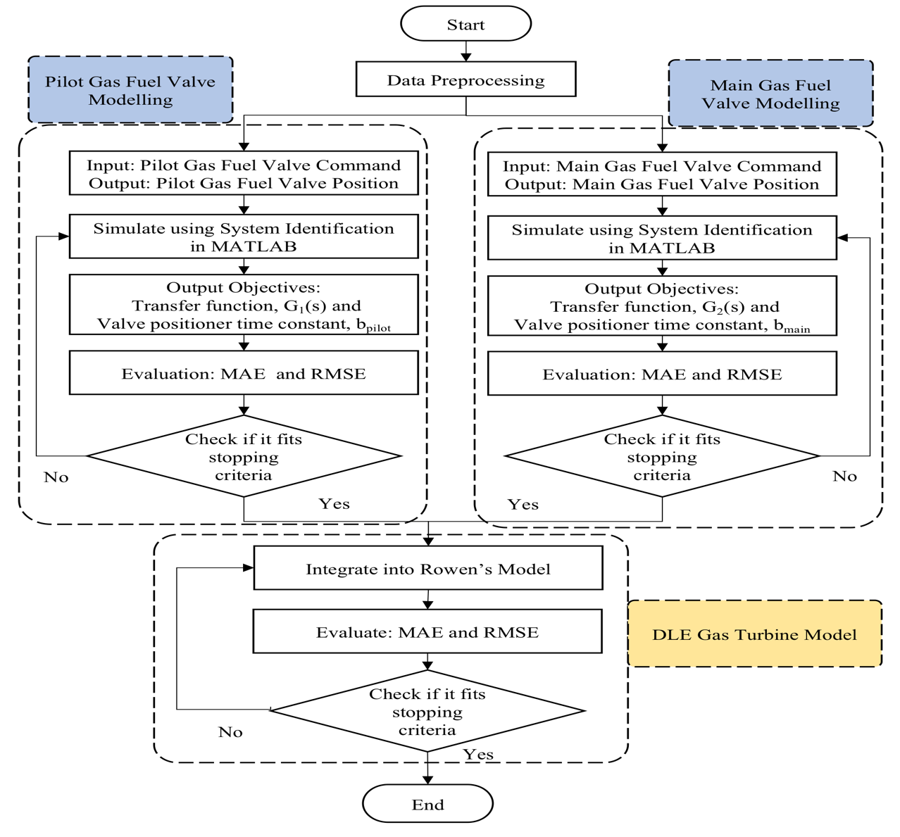
The aforementioned parameters will be utilized to model the DLE gas turbine. The fuel system development consists of three parts, which are pilot gas fuel valve modelling, main gas fuel valve modelling and DLE gas turbine Model. Operational data in August 2016 are collected and only healthy data are considered to model the integration. The data consist of 267804 samples and divided into a training set (50%), testing set (30%) validation set (20%). System structure to model the gas fuel valves is a first-order transfer function as in Equation 1. τ in the equation denotes the time constant for the valve to reach steady state.
(1)
Figure 4: ﻿Flowchart of pilot and main gas fuel valve modelling for DLE gas turbine model.
$$﻿G_{Rowen}\left(s\right)=\frac{1}{τs+1}$$
﻿Based on Tavakoli in [28], the operating time of valve positioner from manufacturer data is assumed at ~200ms and τ is expressed as 0.05. However, in this study, τ for pilot and main gas fuel valves are estimated using system identification in MATLAB. Actual plant data of gas fuel valve input and output signals are tabulated in Table 3.
(1)
Table 3: ﻿Plant data input and output component
Type | Component | Variable | Unit
Input  1 | Pilot Gas Fuel Valve Command | Opening | %
Output  1 | Pilot Gas Fuel Valve Actual Position
Input  2 | Main Gas Fuel Valve Command
Output  2 | Main Gas Fuel Valve Actual Position

﻿The main and pilot gas fuel valves input and output are trained using First Order and Second Order transfer function in system identification. The obtained model, G₁(s) for pilot and G₂(s) for main gas fuel valve are tested using another set of data to determine MAE as in Equation (2) and RMSE as in Equation (3) for error evaluation. y in the equation denotes as actual value and $\hat{y}$ is the predicted value.
(2)
$$﻿MAE=\frac{1}{n}\sum_{i=1}^{n}{\left|y-\hat{y}\right|}$$
(3)
$$﻿RMSE=\sqrt{\frac{1}{n}\sum_{i=1}^{n}{{\left(y-\hat{y}\right)}^{2}}}$$

G₁(s) and G₂(s) are further verified using validation dataset in parameter fit testing to obtain an optimum value of valve positioner time constant, b_{pilot} for pilot and b_{main} for main gas fuel valve model. The proposed transfer functions are fed with input data and the output is compared with the actual output in term of MAE and RMSE. b parameters for both models are increased, decreased and compared with the Rowen's proposed b. The least error of simulated b is selected to represent the pilot and main gas fuel valve model.
﻿After the development of pilot and main gas fuel valve model as covered in Section 3.1, both models are integrated into Rowen's gas turbine model in Section 3.2 to imitate the actual DLE gas turbine fuel system and operation. Rowen gas turbine model for this study is illustrated in Figure 5. The transfer functions are calculated using the nominal and operational values according to [28]﻿Rowen's model functions for the simulation are the turbine exhaust flow as calculated in Equation (4), with T_{R} as the turbine rated exhaust temperature, 950°F, N is the speed signal line and W_{f} is the fuel flow line,
(4)
$$﻿f_{1}=T_{R}-\left(700\left(1-W_{f}\right)+550\left(1-N\right)\right)$$

﻿turbine torque is calculated from Equation (5),
(5)
$$﻿f_{2}=1.3\left(W_{f}-0.23\right)+0.5\left(1-N\right)$$

﻿and turbine exhaust flow calculation as in Equation (6) with L_{IGV} as the IGV opening and T_{a} is the ambient temperature, 59°F.
(6)
$$﻿f_{3}=N\left({L_{IGV}}^{0.257}\right)\left(\frac{519}{T_{a}+460}\right)$$
﻿After the integration of the gas fuel system for DLE gas turbine, the model is simulated using one-day actual load change and ambient temperature. The simulated signals of pilot and main gas fuel valves, engine fuel flow and turbine temperature are compared with the actual data using MAE and RMSE analysis to measure the model accuracy. The simulated speed signal also analyzed for system stability measurement by maintaining at 1.0 p.u throughout the simulation. The proposed DLE gas turbine model is expected to have 99% accuracy to represent the actual operation for stability study, fault analysis and detection and fault prediction. The results are presented and discussed in Results and Discussion section.

- Results and Discussion
﻿This section is divided into two parts; pilot and main gas fuel valve modelling in Section 3.1 and DLE gas turbine model with the integrated fuel system in Section 3.2.
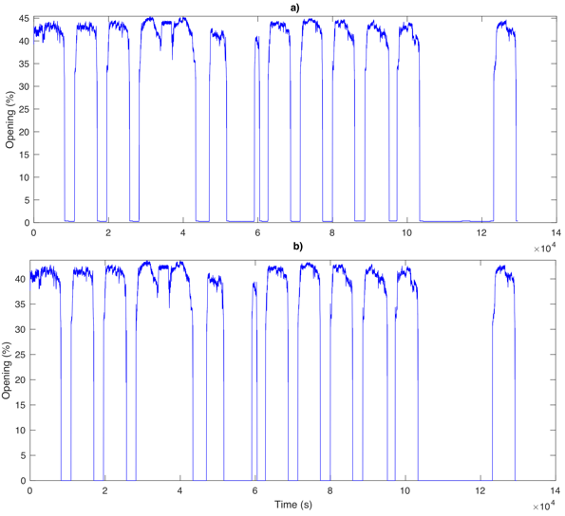
  - Pilot and Gas Fuel Valve Modelling
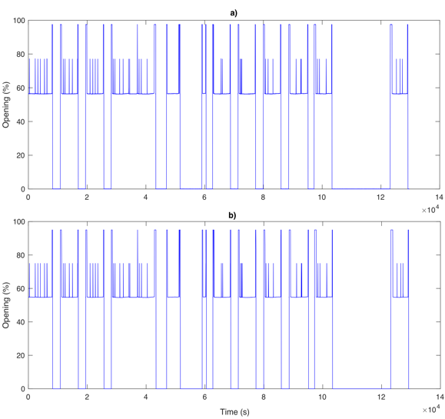
﻿Pilot valve training dataset is illustrated in Figure 5 with the output trend in (a) and an input trend in (b). As the data represent 15 days of the DLE gas turbine operation, the 0% opening indicates the shutdown of the gas turbine and step up to 100 for the start-up. The pilot valve is constant at 55% after the load has reached 50% of the capacity for dry-low emission mode. The valve also exhibits some spikes during the operation and the input and output of the valve have identical behavior.
Figure 5: ﻿Main gas fuel valve training output.
﻿Even though Rowen's model has a main fuel valve model, it is still required to perform system identification to investigate the actual DLE main valve behavior. The main valve training dataset is shown in Figure 6 with the output in (a) and input in (b).
Figure 6: ﻿ ﻿Pilot gas fuel valve a) Ten days and b) zoomed-in testing data.
The trend is also identical between the input and the output. The shutdown lies in 0% opening and start-up to 40-45% opening. However, it does not change from any position to a specific position even though the turbine is in DLE mode as compared with the pilot gas fuel valve. Thus, the main function of the pilot gas fuel valve in sustaining low emission is proven from the actual behavior of DLE gas turbine operation.
Pilot gas fuel valve testing result is shown in Figure 7(a) ten days and (b) zoomed in signal.
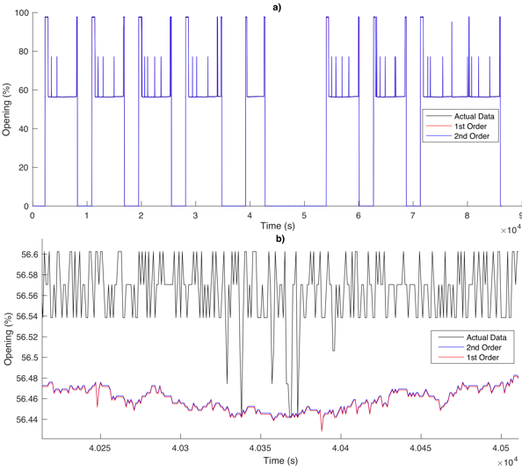
Figure 7: Pilot gas fuel valve training output.
﻿

From the 10 days analysis, both first and second-order system accurately estimates the shutdown, start-up and the transition mode to DLE. The accuracy is contributed from the linear operation of the input and output of the valve. Signal spikes also estimated close to the actual operation. With the zoomed in to 2 decimal places of opening, it can be observed that the second-order transfer function exhibits a closer estimation of the actual data compared to the first-order transfer function. This is due to the more order added to the function, more accurate the estimation will become. Even though the trend of the actual signal is not precisely estimated into 2 decimal places, the ten days signal proves the ability of the model to represent the pilot gas fuel valve operation.
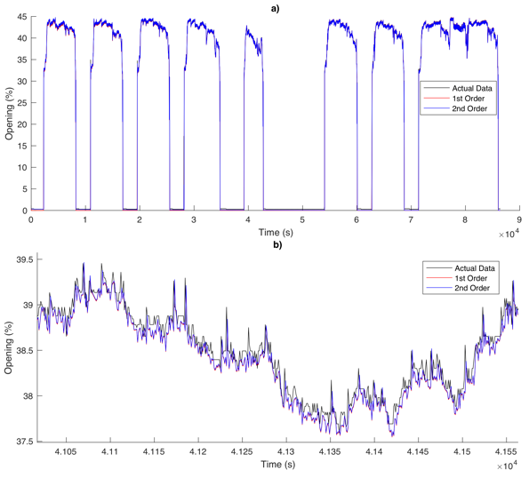
Main gas fuel valve is also tested using the testing dataset and the result is illustrated in Figure 8 a) ten days and b) zoomed-in signal.
Figure 8: ﻿Main gas fuel valve a) ten days b) zoomed in testing result.

﻿It can be observed that the second-order transfer function exhibits a closer estimation of the actual data compared to the first-order transfer function similar to the pilot gas fuel valve analysis. The proposed model is able to estimate the trend both in 10 days and in zoomed in. The simulated pilot and main gas fuel models are further compared with the actual value using MAE and RMSE analysis as tabulated in Table 4. Second-order system and first-order system's error are almost the same with a very small deviation for both of the training and testing results of pilot and main gas fuel valve.
Transfer Function | Set | Pilot Gas Fuel Valve
 |  | MAE | RMSE
1st Order | Training | 4.35 | 1.3358
2nd Order | Testing | 4.57 | 1.3358
1st Order | Training | 4.35 | 1.3358
2nd Order | Testing | 4.57 | 1.3356
Transfer Function | Set | Main Gas Fuel Valve
 |  | MAE | MAE
1st Order | Training | 2.02 | 2.02
2nd Order | Testing | 2.02 | 2.02
1st Order | Training | 1.95 | 1.95
2nd Order | Testing | 1.95 | 1.95
Table 4: ﻿Pilot and main gas fuel valve error analysis.

﻿Hence, the first-order transfer function is preferable due to low complexity and the accuracy of the estimations are almost the same with the second-order system. Therefore, the pilot gas fuel valve model is expressed in Equation (7) and the main gas fuel valve model is shown in Equation (8).
(7)
$$﻿G_{1}\left(s\right)=\frac{1}{0.172s+1}$$
(8)
$$﻿G_{2}\left(s\right)=\frac{1}{0.222s+1}$$

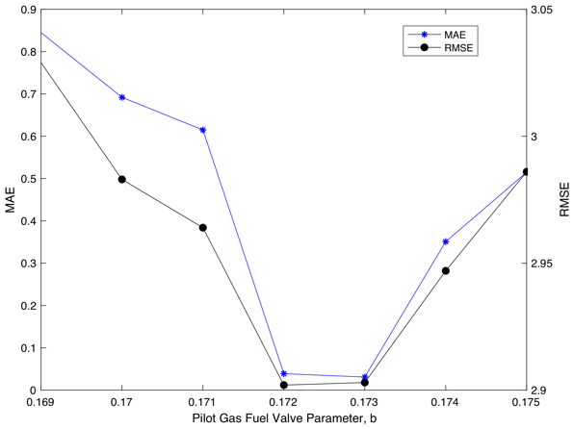
﻿The proposed models from system identification are further validated using validation dataset in parameter testing to determine the best $\tau$. First evaluation is the comparison of the proposed system identification model with Rowen's model as in Table 5. The proposed system identification parameters, b for both pilot and main gas fuel valves shown a very high accuracy with improved MAE and RMSE compared to Rowen's parameter assumption.
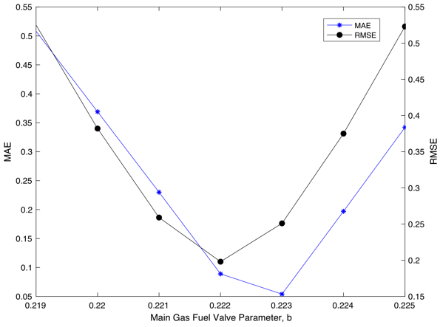
Table 5: Parameter fit testing of pilot and main gas fuel valve.
Figure 9: ﻿ Gas fuel valve parameter fit testing result for pilot gas fuel valve.
Figure 10: Main gas fuel valve parameter fit testing result for main gas fuel valve.
 | Pilot Gas Fuel Valve
 | b | MAE | RMSE
Rowen | 0.050 | 1.350 | 3.244
System Identification | 0.172 | 0.039 | 2.902
 | Main Gas Fuel Valve
 | b | MAE | RMSE
Rowen | 0.050 | 1.324 | 1.432
System Identification | 0.222 | 0.089 | 0.198

Parameter fit testing for the system identification model for pilot and main gas fuel valve are illustrated in Figure 10 and Figure 11 respectively. Pilot gas fuel valve analysis indicates that the optimum parameter can be 0.172 as proposed or 0.173. MAE and RMSE for the analysis are increased when the parameter is below or higher than the optimum value.
For this study, 0.173 is selected due to low MAE and low RMSE compared to the proposed, 0.172.
Two optimum values also observed in main gas fuel valve parameter analysis at 0.222 as proposed and 0.223. However, parameter 0.222 exhibits low RMSE high MAE compared to parameter 0.223 with high RMSE but low MAE. In this scenario, low RMSE is desirable compared to MAE to produce a low variance of the individual errors in the sample. Thus, 0.222 remained as proposed for main gas fuel valve parameter.
This section ends until the valves model are acquired and it is substituted into Rowen's model to build a DLE gas fuel valve system.

  - DLE Gas Turbine Fuel System
﻿In this section, the actual representation and operation of pilot and main gas fuel valves were further investigated.
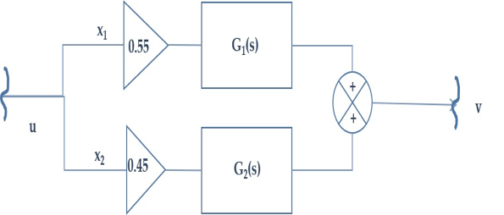
The first study is the normal operating behavior of the valves as presented in Figure 11. The trend lies in 55% opening and the main gas fuel valve, is at 40%.
Figure 13: DLE gas turbine valve positioner function for Rowen's integration.
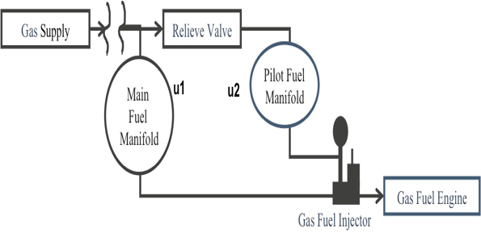
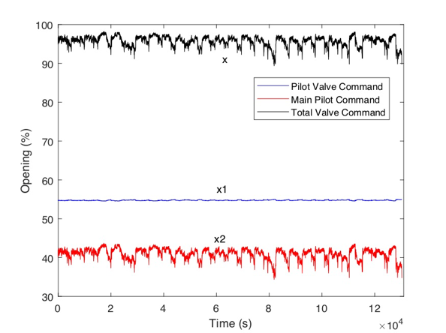
﻿The total opening of the valve is around 95\% and this converted as a basis ratio for the valve modelling in DLE gas turbine. The ratios of the valves are approximated at 0.45 for the main valve and 0.55 for the pilot gas fuel valve. Apart from the operation, the actual setup of the valves in the DLE gas turbine package was examined as shown in Figure 12.
Figure 12: ﻿ DLE gas turbine fuel system representation DLE gas turbine ratio of main and pilot valve opening during operation.
Figure 11: DLE gas turbine ratio of main and pilot valve opening during operation.
﻿The main gas supply is the source for the system, and it goes to the main and pilot fuel manifold. Fuel flow from both valves are sent to the gas fuel injector and a relief valve also installed to prevent overpressure. From the representation, it can be justified that both valves are working parallel to each other for the ignition. Based on the operation and the actual setup, valve positioner function was proposed as in Figure 13 with G_{1(s)} as the pilot gas fuel valve model and G_{2(s)} as the main gas fuel valve model. The ratio of the valves is approximated at 0.45 for the main valve and 0.55 for the pilot gas fuel valve accordingly. The sum of the valves values is sent to the fuel system. The proposed transfer functions for the valves are integrated into Rowen's model with the specified ratio. The integration of the proposed structure of the DLE gas fuel system into Rowen's model is presented in Figure 14.
Figure 15: ﻿DLE gas turbine load change input for one day.
All parameters of the transfer function are calculated according to the case study of the selected DLE gas turbine. One day load change from another set of data is fed to Rowen's model as an input as illustrated in Figure 15.
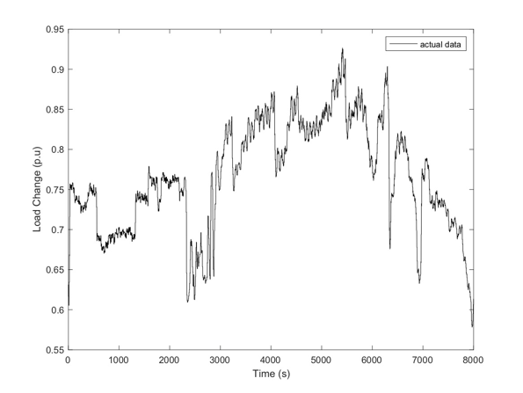
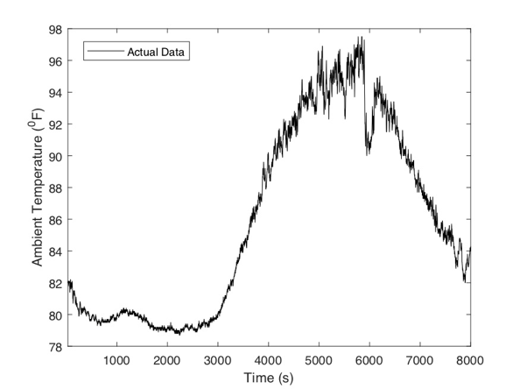
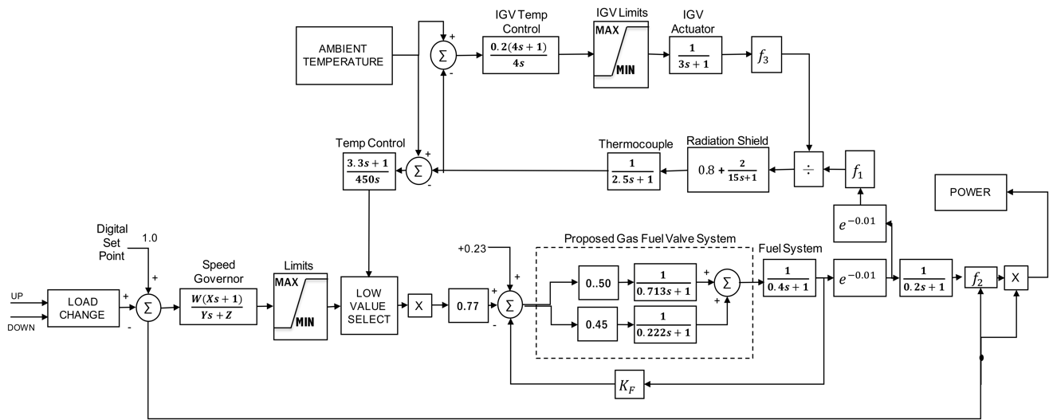
﻿ The trend indicates the low and high demand profile, usually in the middle of the day where all academic and research work took place. The second input for the integration is ambient temperature as in Figure 16. The value is at 80$℉$in midnight and increases to a peak at 96$℉$ during the daytime. This is the actual temperature in Malaysia and the profile is almost the same each day due to the climate condition in the country. This input is fed to Rowen's model alongside with the actual load demand to simulate main and pilot gas fuel valves, engine gas fuel flow and temperature average signals. The simulated signals are compared with the actual data using MAE and RMSE analysis to measure the model accuracy. The results of the simulated outputs are compared with the actual value. Gas turbine speed for the turbine is stable at 1 p.u or 100% as a constant speed
Figure 14: ﻿The integration of main and pilot gas fuel valve into the Rowen's model.

Figure 16: ﻿DLE gas turbine ambient temperature input for one day.

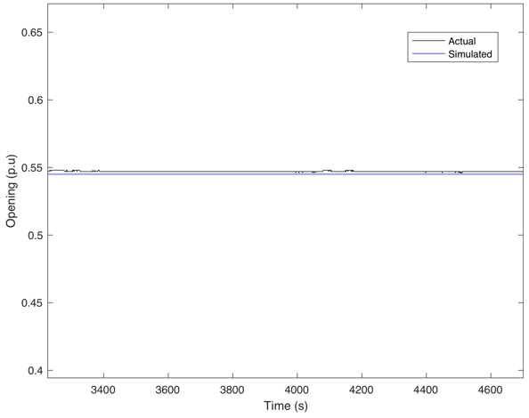  (a) | 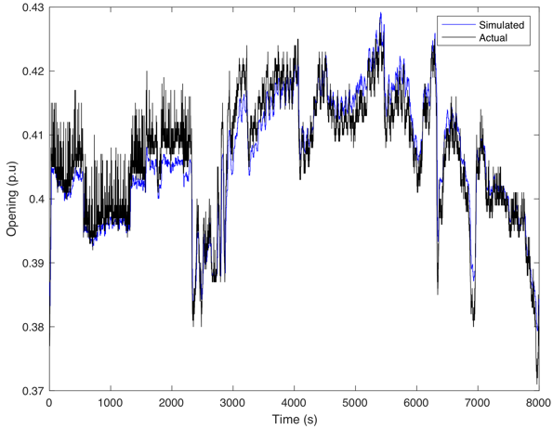  (b)
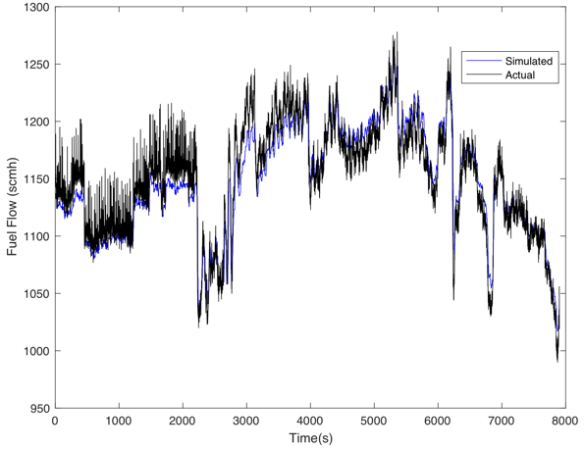  (c) | 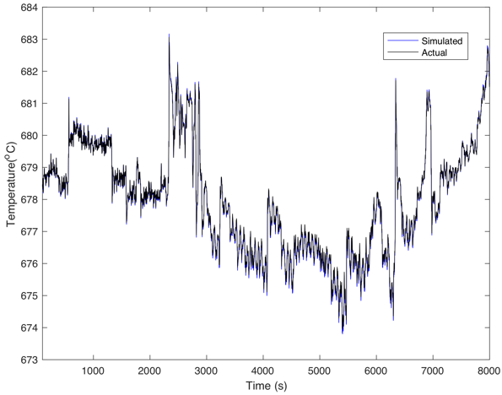  (d)
Figure 17: ﻿Simulated and actual results of (a)pilot valve, (b)main valve, (c)engine fuel flow and (d)turbine temperature.
﻿ The first output to be investigated is the pilot gas fuel valve as illustrated in Figure 17(a). The actual data lies in 0.55p.u opening, and the simulated data is projected very close to it.
The second output is the main gas fuel valve and the result is shown in Figure 17(b). The simulated trend exhibits a good estimation of the actual trend with an only small deviation. As both of the trends are compared, the pilot gas fuel valve remains constant at 0.55 for DLE mode but the main gas fuel valve is modulated according to the load demand in Figure 15.
The third output to be investigated is the engine fuel flow as shown in Figure 17(c). The simulated signal captures the same trend of the actual signal and indicates its capability to represent DLE gas turbine operation. The signals imitate the load signal according to the gas turbine operation; which increases the fuel flow demand when the load increases.
Last output to be investigated is the thermocouple temperature. This output also crucial in a DLE gas turbine due to the rigid control of the temperature that must lie in the targeted temperature zone to reduce the ﻿ emission. ﻿The temperature of the gas turbine was closely monitored during the operation compared to the conventional gas turbine that normally unattended. The result of the simulated temperature is illustrated in Figure 17(d). A good fit of the simulated temperature profile is observed from the trend. This indicates that the introduction of the pilot and main gas fuel valves does not deteriorate the performance of the temperature profile of the DLE gas turbine.
﻿The simulation outputs are further analyzed in term of MAE and RMSE and the values are tabulated in Main gas fuel valve, pilot gas fuel valve and temperature average signals exhibits very high accuracy with an error less than 0.1 for both MAE and RMSE. Engine gas fuel flow carried quite high error compared to the three signals with MAE is 1.644 and RMSE 17.85. This is due to the inheritance error from pilot and main gas fuel valve that carries into the engine fuel flow measurement. However, the signal performance is still acceptable for this study due to the good trend fit to the actual signal. The error analysis proves that the simulated signals are accurate enough to represent the real DLE gas turbine operation.
Table 7: MAE and RMSE analysis for the simulated output compared to the actual signal.
 | MAE | RMSE
Main Gas Fuel Valve | 0.0031 | 0.005
Pilot Gas Fuel Valve | 0.0026 | 0.0027
Engine Gas Fuel Flow | 1.644 | 17.85
Temperature Average | 0.0355 | 0.058

- Conclusion
﻿DLE gas turbine is introduced to achieve a low emission operation where a pilot gas fuel valve is added to the fuel system. However, the turbine is susceptible to frequent trips and a dynamic model for operational representation is required. In this modelling study, a DLE gas turbine fuel system model was proposed for operational study using First Principle Data-Driven (FPDD) method. First-order and second-order in system identification are tested to model the valves. First-order and second-order transfer function produce an accurate estimation of the pilot and main gas fuel valves. However, the first-order transfer function is selected to model the pilot and main gas fuel valves due to its simplicity and the priori structure of the Rowen's model. The proposed valve models are integrated into Rowen's model according to the real structure gas fuel system. From the integration, pilot and main gas fuel valves, turbine temperature and gas fuel flow signals are compared with the actual signal. The outputs of the model capture the actual trend accurately with a very low MAE and RMSE. With the accurate DLE gas turbine model, the frequent trip can be prevented by a prediction model that utilizes the simulated data. Future work in modelling a pressure compressor discharge is recommended.

Acknowledgement
﻿The authors acknowledge the support of Ministry of Higher Education (MOHE) and Universiti Teknologi PETRONAS in carrying out this research through the FRGS 0153AB-L31 grant.
References

[1] A. Suman, N. Casari, E. Fabbri, M. Pinelli, L. Di Mare, and F. Montomoli, "Gas Turbine Fouling Tests: Review, Critical Analysis, and Particle Impact Behavior Map," Journal of Engineering for Gas Turbines and Power, vol. 141, no. 3, p. 032601, 2019.
[2] R. Rigo-Mariani, C. Zhang, A. Romagnoli, M. Kraft, K. V. Ling, and J. M. Maciejowski, "A Combined Cycle Gas Turbine Model for Heat and Power Dispatch Subject to Grid Constraints," IEEE Transactions on Sustainable Energy, 2019.
[3] T. Hazel, G. Peck, and H. Mattsson, "Industrial Power Systems Using Dry Low Emission Turbines," Industry Applications, IEEE Transactions on, vol. 50, no. 6, pp. 4369-4378, 2014.
[4] A. Abdelhafez, S. S. Rashwan, M. A. Nemitallah, and M. A. Habib, "Stability map and shape of premixed CH4/O2/CO2 flames in a model gas-turbine combustor," Applied Energy, vol. 215, pp. 63-74, 2018.
[5] S. I. Serbin, I. B. Matveev, and G. B. Mostipanenko, "Investigations of the Working Process in a &#x201C;Lean-Burn&#x201D; Gas Turbine Combustor With Plasma Assistance," Plasma Science, IEEE Transactions on, vol. 39, no. 12, pp. 3331-3335, 2011.
[6] G. Peck, "Challenges in using waste heat recovery and DLE combustion to reduce CO2 &#x00026; NOX emissions," in 2009 Conference Record PCIC Europe, 26-28 May 2009 2009, pp. 35-43[Online].
[7] J. C. Massey, Z. X. Chen, and N. Swaminathan, "Lean flame root dynamics in a gas turbine model combustor," Combustion Science and Technology, pp. 1-24, 2019.
[8] N. Zettervall, N. Worth, M. Mazur, J. Dawson, and C. Fureby, "Large eddy simulation of CH4-air and C2H4-air combustion in a model annular gas turbine combustor," Proceedings of the Combustion Institute, vol. 37, no. 4, pp. 5223-5231, 2019.
[9] M. M. Mohamed Iqbal, S. Sarumathi, K. R. Jothi, and A. Brindadevi, "Model order reduction of heavy duty gas turbine power plants with field test parameters," International Transactions on Electrical Energy Systems, vol. 29, no. 2, p. e2703, 2019.
[10] I. E. Cáceres, R. M. Montañés, and L. O. Nord, "Flexible operation of combined cycle gas turbine power plants with supplementary firing," Journal of Power Technologies, vol. 98, no. 2, pp. 188-197, 2018.
[11] A. Chaibakhsh and S. Amirkhani, "A simulation model for transient behaviour of heavy-duty gas turbines," Applied Thermal Engineering, vol. 132, pp. 115-127, 2018.
[12] M. Rahman, V. Zaccaria, X. Zhao, and K. Kyprianidis, "Diagnostics-Oriented Modelling of Micro Gas Turbines for Fleet Monitoring and Maintenance Optimization," Processes, vol. 6, no. 11, 2018, Art no. 216.
[13] T. S. Kim, "Model-based performance diagnostics of heavy-duty gas turbines using compressor map adaptation," Applied energy, vol. 212, pp. 1345-1359, 2018.
[14] M. Montazeri-Gh, S. A. M. Fashandi, and S. Abyaneh, "Real-time simulation test-bed for an industrial gas turbine engine's controller," Mechanics & Industry, vol. 19, no. 3, 2018.
[15] Z. Liu and I. A. Karimi, "Simulating combined cycle gas turbine power plants in Aspen HYSYS," Energy Convers. Manage., vol. 171, pp. 1213-1225, 2018.
[16] T. S. Pires, M. E. Cruz, M. J. Colaco, and M. A. C. Alves, "Application of nonlinear multivariable model predictive control to transient operation of a gas turbine and NOX emissions reduction," Energy, vol. 149, pp. 341-353, 2018.
[17] Y. Soon Kiat, J. V. Milanovic, and F. M. Hughes, "Overview and Comparative Analysis of Gas Turbine Models for System Stability Studies," Power Systems, IEEE Transactions on, vol. 23, no. 1, pp. 108-118, 2008.
[18] F. J. Gomez, M. A. Chaves, L. Vanfretti, and S. H. Olsen, "Multi-Domain Semantic Information and Physical Behavior Modeling of Power Systems and Gas Turbines Expanding the Common Information Model," Ieee Access, vol. 6, pp. 72663-72674, 2018.
[19] D. Huang, J. W. Chen, D. J. Zhou, H. S. Zhang, and M. Su, "Simulation and analysis of humid air turbine cycle based on aeroderivative three-shaft gas turbine," Journal of Central South University, vol. 25, no. 3, pp. 662-670, 2018.
[20] M. H. M. Tarik, M. Omar, M. F. Abdullah, and R. Ibrahim, "Modelling of dry low emission gas turbine using black-box approach," in IEEE Region 10 Annual International Conference, Proceedings/TENCON, 2017, vol. 2017-December, pp. 1902-1906[Online].
[21] S. K. Yee, J. V. Milanović, and F. M. Hughes, "Overview and comparative analysis of gas turbine models for system stability studies," IEEE Transactions on Power Systems, Review vol. 23, no. 1, pp. 108-118, 2008.
[22] M. Pondini, A. Signorini, V. Colla, and S. Barsali, "Analysis of a simplified Steam Turbine governor model for power system stability studies," Energy Procedia, vol. 158, pp. 2928-2933, 2019.
[23] M. Omar, M. H. M. Tarik, R. Ibrahim, and M. F. Abdullah, "Suitability study on using rowen's model for dry-low emission gas turbine operational performance," in TENCON 2017 - 2017 IEEE Region 10 Conference, 5-8 Nov. 2017 2017, pp. 1925-1930[Online].
[24] J. Hermann, M. Greifenstein, B. Boehm, and A. Dreizler, "Experimental investigation of global combustion characteristics in an effusion cooled single sector model gas turbine combustor," Flow, Turbulence and Combustion, vol. 102, no. 4, pp. 1025-1052, 2019.
[25] P. Czop, G. Kost, D. Sławik, and G. Wszołek, "Formulation and identification of first-principle data-driven models," Journal of Achievements in materials and manufacturing Engineering, vol. 44, no. 2, pp. 179-186, 2011.
[26] P. Czop, D. Sławik, and G. Wszołek, "Demonstration of First-Principle Data-Driven models using numerical case studies," Journal of Achievements in Materials and Manufacturing Engineering, vol. 45, no. 2, pp. 170-177, 2011.
[27] R. Winter, F. Montanari, F. Noé, and D.-A. Clevert, "Learning continuous and data-driven molecular descriptors by translating equivalent chemical representations," Chemical science, vol. 10, no. 6, pp. 1692-1701, 2019.
[28] M. R. B. Tavakoli, B. Vahidi, and W. Gawlik, "An Educational Guide to Extract the Parameters of Heavy Duty Gas Turbines Model in Dynamic Studies Based on Operational Data," Power Systems, IEEE Transactions on, vol. 24, no. 3, pp. 1366-1374, 2009.

