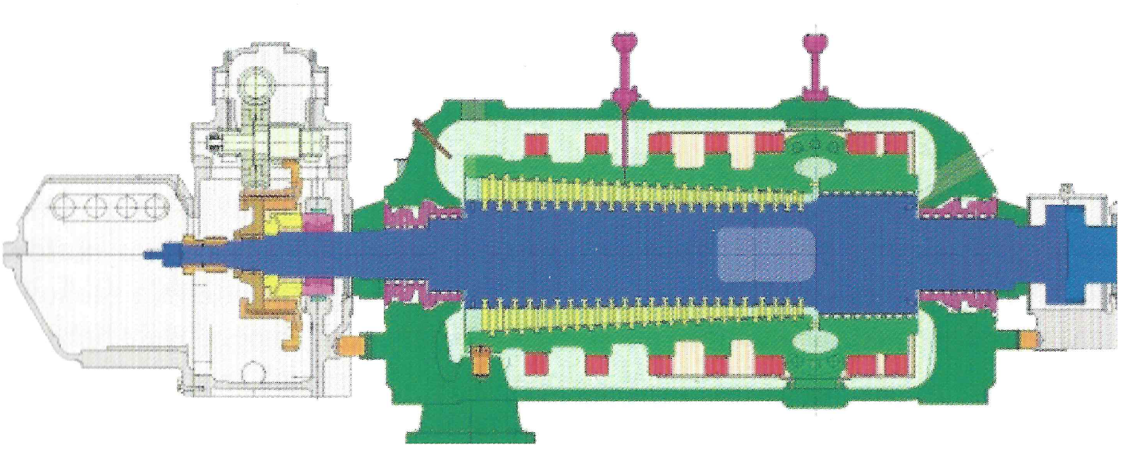
Fig. 1. Cross section of the turbine’s 18K390 HP part [15]

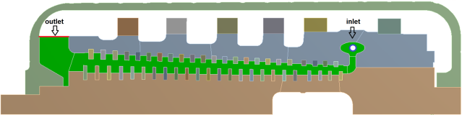
Fig. 2. Reference model of the WP part of the 18K390 turbine with marked inlet and outlet edges

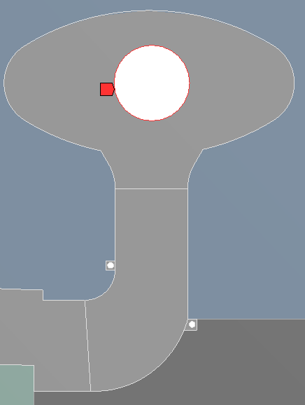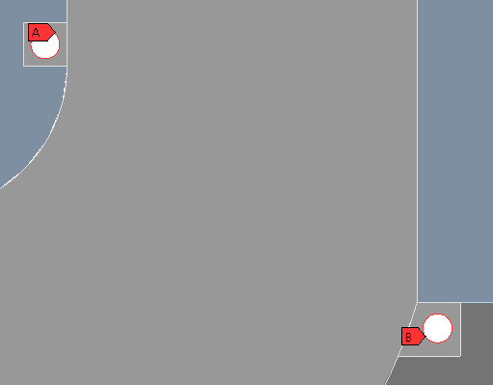
Fig. 3. Close-up to the area of additional inlets

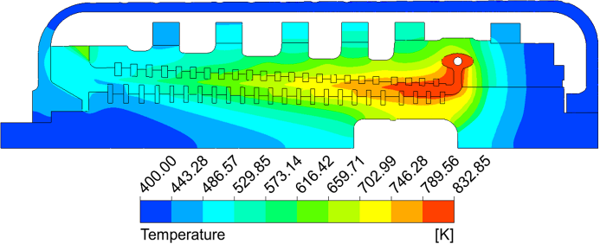
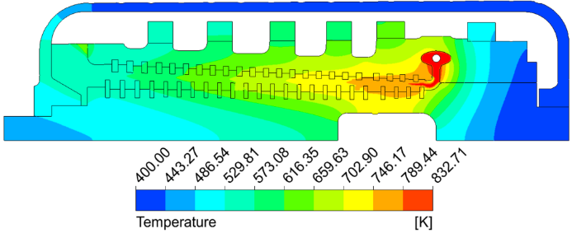

Fig. 4. Distribution of the temperature field in the 180th minute of start-up 3h. On the top, starting without the injection of cooling steam, bottom side with the injection of cooling steam.

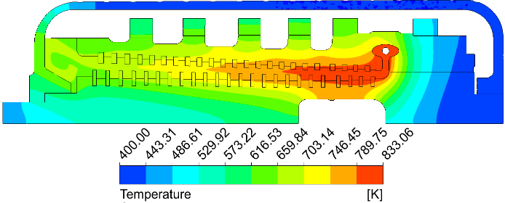
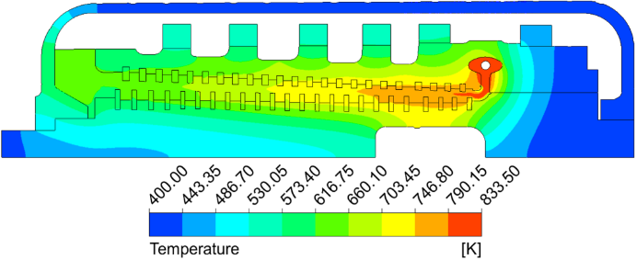
Fig. 5. Distribution of the temperature field in the 120th minute of start-up 2h. On the top side, starting without the injection of cooling steam, bottom side with the injection of cooling steam.

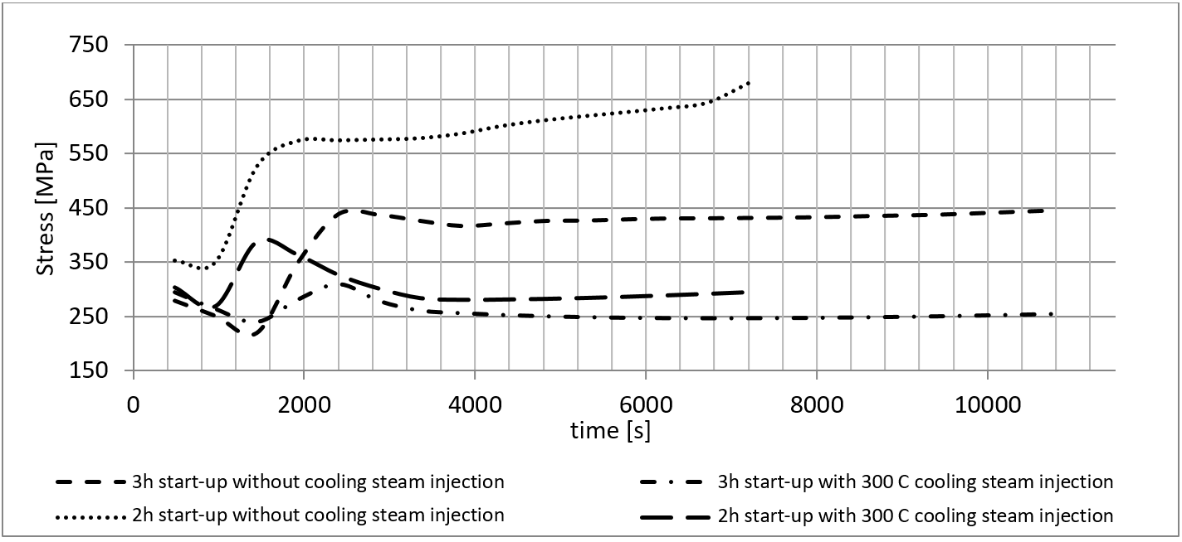
Fig. 6. H-M-H stress course during turbine strat-up.

