Communication Assisted Fuzzy based Adaptive Protective Relaying Scheme for Microgrid
B.K. Chaitanya, Atul Kumar Soni and Anamika Yadav*
Department of Electrical Engineering, National Institute of Technology Raipur, C.G., India
(*corresponding author e-mail: ayadav.ele@nitrr.ac.in)

Abstract
This study proposes a communication assisted fuzzy based adaptive protective relaying scheme for fault detection, fault classification and faulty phase identification of microgrid along with a solution to isolate the microgrid from utility grid by disconnecting the static-switch. For any fault in utility grid, microgrid gets isolated from the utility grid and for a fault in the microgrid continues to operate with utility grid. Adaptive fuzzy inference system has been developed using separate fuzzy rule base for the two modes of operation of microgrid i.e. islanded mode or grid connected mode. The Central Grid Status Communication System (CGSCU) is considered which monitors the status of PCC and sends a command signal to the relays so that the relay settings get updated with new rules for any transition in the mode of microgrid. The fundamental phasor amplitude and zero sequence component of current signals are used as input features fault detection, fault classification and faulty phase identification. A standard microgrid model IEC 61850-7-420 has been simulated using MATLAB/SIMULINK. The proposed method is tested for all types of faults by varying fault parameters and also for dynamic situations like, connection/disconnection of DGs and loads. The test results substantiate effectiveness of the method.

Keywords: Fault Detection, Fault Classification, Fuzzy Inference System (FIS), Grid Connected Mode, Islanded Mode, Microgrid.

- Introduction
In the present scenario in order to meet the increasing power demand the existing power network is integrated with a microgrid consisting of low voltage distributed generating units feeding some local loads. This has increased the complexity but, at the same time improved the reliability of the system. A microgrid consists of the distributed generated (DG) units, such as, wind, fuel cell, photovoltaic cell, diesel generators etc., along with some local storage so as to achieve an independent control of power over a particular area [1]. Major advantages of microgrid include reduced transmission losses and greenhouse gases [2]. Microgrids operate in two modes either independently or connected to the grid. Microgrid connected to the utility grid constitutes grid connected mode (GCM) and its disconnection can be constituted as Islanded mode (IM). The power flow gets affected upon the occurrence of fault in the network [3], which affects the conventional relaying schemes that no longer support in the aspect of microgrid protection.
There is a very limited literature available in the prospect of microgrid protection as compared with high voltage power system networks. A fault detection strategy based on monitoring the transient response of the inverter current waveform using a transient monitoring function (TMF) has been proposed in [4] but it requires an extra auxiliary control system at the inverter. In [5], S-transform based protection scheme using differential energy is proposed which has been applied in the two modes of operation of microgrid but has the limitation of increased computation time. In [6], another differential energy based protection scheme has been proposed using Hilbert–Huang transform which detects the fault instant to issue trip decision without classifying the fault type. Data-mining based protection scheme for microgrid has been presented in [7-8] but require more number of features for training. In [9], a microgrid protection scheme that depends on evolutionary computation technique for relay co-ordination has been used. In [10], a protection and relay coordination scheme using sequence components has been implemented. The relay coordination makes the scheme more complex. A protection strategy based on microprocessor-based relays for low-voltage microgrids has been presented in [11].
Some adaptive and communication based approaches have also been developed. In [12], an adaptive protection scheme has been proposed which works effectively when penetration level of DG is more but is not tested in islanded mode of operation. In [13], a ring architecture network integrated with microgrid and an adaptive zonal protection scheme has been described. In [14], an adaptive directional overcurrent relaying technique based on the positive-sequence (PSQ) and negative-sequence (NSQ) superimposed currents is proposed for microgrid protection. In [15], communication assisted digital relays have been implemented for microgrid protection which uses differential current scheme which does not consider time synchronisation. Communication strategy based differential protection scheme using symmetrical components has been proposed in [16], for microgrid operating only in islanded mode. In [17], a microgrid protection scheme using communication and coordination between relays and distributed generators has been proposed which requires the relay settings to change for any change in the grid configuration. Another technique based on fisher information which measures the stability of the electric signals and combined with wavelet analysis for faulty phase selection of a power distribution network [18]. The optimal planning and clustering of smart low-voltage distribution networks into autonomous microgrids within a greenfield area is discussed in [19] using imperialist competitive algorithm.
After reviewing various schemes for protection of microgrid, it is observed that, most of the researchers have focused on fault detection issue only and not considered the fault classification or faulty phase selection. The communication system provides an additional advantage in the protection aspect of microgrid which can be used in conjunction with fuzzy rule base. In view of this, the main aim of this paper is not only to detect the presence of fault in both grid connected mode and islanded mode of operation of microgrid, but also to classify the fault type and identify the faulty phase(s) of the microgrid. This paper deals with a communication assisted fuzzy based adaptive protective relaying scheme, in a microgrid which has been studied on a standard IEC 61850-7-420 model [20]. The proposed methodology initially identifies the presence of fault, whether in the microgrid or utility grid. For a fault in the utility grid, the microgrid gets disconnected from the utility grid and operates in islanded mode, while for a fault in the microgrid it continues to operate in grid connected mode and should be able to properly identify the fault type so as to eliminate the faulty phase by selective phase tripping. The fundamental phasor amplitudes and sequence components of the current signals are extracted which are used as the input features for the protection scheme which detects the fault and faulty phase(s) rapidly and thereby enables single pole tripping function in case of single line to ground fault without interrupting the unaffected phases.
- Microgrid Model
A single line diagram of microgrid system is shown in Fig. 1. The details of the microgrid system are considered as in [8]. It consists of utility grid of rating 2500 MVA, 120 kV and three DG units. The first DG unit (DG-1) is wind power based of 6 MW capacity. The other two include the photovoltaic cell based solar power DG units (DG-2 & DG-3) of 1 MW each. The system operating frequency is 60 Hz. Pi-section lines have been used for the interconnections and loads have been connected at the respective buses as shown in the figure.

Fig. 1. Schematic diagram of Microgrid according to IEC 61850-7-420.

- Proposed Methodology
The complete flowchart of the proposed protective relaying scheme is shown in Fig.2. The proposed methodology starts with the identification of the fault whether present in the microgrid or utility grid. For a fault in the utility grid, the microgrid is to be disconnected from the utility grid and must operate in islanded mode. And for a fault in the microgrid it should continue to operate in grid connected mode and should be able to correctly identify the fault type and faulty phase so as to enable selective phase tripping without affecting other healthy phases in case of single line to ground fault. The fundamental phasor amplitudes and sequence components of the current signals are extracted using the recursive DFT pre-processor and sequence analyzer respectively which are used as the input features for the proposed fuzzy based protection scheme.

Fig.2 Flowchart of proposed protective relaying scheme.

  - Design of Fuzzy Based Fault Identifier for Fault in Utility Grid/Microgrid (FIS-1)
The presence of fault in the system is determined using the positive sequence phase angle (Φ) of current at bus-1 which determines whether the fault is present in utility grid or microgrid. Φ_{LOW}, Φ_{MEDIUM} and Φ_{HIGH} are the three ranges of phase angle which are selected using triangular member function which determines the presence of fault in the utility grid or microgrid. In this study Mamdani type FIS has been used. FIS-1 is designed for this task which shows ‘0’ for no fault, ‘1’ for a fault in the microgrid and ‘−1’ for a fault in the utility grid. Three rules used for fault identifier are:-

- If phase angle is Φ_{LOW} then output is ‘-1’ (trip is T_{UG})
- Fault is in the utility gird, isolate from microgrid from utility grid
- If phase angle is Φ_{MEDIUM} then output is ‘0’ (trip is T_{N})
- No fault in the system, continue to operate without disconnecting the microgrid from utility grid
3. If phase angle is Φ_{HIGH} then output is ‘1’ (trip is T_{N-GCM})
- Fault is in the microgrid, then identify the faulty phase by continuing to operate without disconnecting the microgrid from utility grid.
For a fault in the utility grid, the microgrid gets separated from the utility grid and should operate in islanded mode and further identify the fault in the utility grid in order to restore the power and reconnect to the microgrid. For a fault in microgrid, it can operate in grid connected mode and further identify the faulty phase(s). And for a fault in microgrid in the islanded mode, adaptive fuzzy module which is explained in subsequent section deals with the protective relaying of microgrid.

  - Central Grid Status Communication Unit and Adaptive Fuzzy Inference System-Module
The characteristics of the fault currents are separate for the two modes of operation of the microgrid. In GCM the magnitude of currents in the system are high due to the contribution from utility grid, but in IM mode the disconnection of utility grid reduces the magnitude of currents. This distinct characteristic of the fault currents in the two modes of microgrid paves a need to design separate fuzzy rule base which is designed as an Adaptive Fuzzy Inference System-Module (AFIS-Module) to protect the microgrid. AFIS-Module is placed at each section of the distribution lines. Each AFIS-Module consists of two fuzzy inference systems (FIS-2 & FIS-3), where FIS-2 is specified for the grid-connected mode and FIS-3 for islanded mode. Depending upon the mode of operation of the microgrid the fuzzy rule base FIS-2 gets activated for GCM and FIS-3 for IM of operation. Central Grid Status Communication Unit (CGSCU) as illustrated in Fig.3 is a processing unit used for communicating the status of the grid for the updation of the fuzzy rules for relays to operate effectively.
Fig.3 Central Grid Status Communication Unit (CGSCU) for AFIS-Module.

CGSCU monitors the status of PCC whether the utility grid is connected or disconnected to the microgrid. Depending upon the status of PCC, the CGSCU sends an interrupt to perform an updation of the fuzzy rule base of relays with suitable settings (FIS-2 for GCM and FIS-3 for IM) for the purpose of issuing accurate trip decision.
  - Design of Fuzzy Inference Systems (FIS-2 & FIS-3) for Faulty Phase Selection and Classification
Based on the output of FIS-1, CGSCU sends interrupt to the relays for the updation of fuzzy rule base corresponding to the mode of operation of the microgrid. For the microgrid operating in GCM, the FIS-2 gets activated and for the islanded mode FIS-3 gets activated. Each FIS includes separate rules for the detection of faulty phase(s) and ground fault detection, thereby classifying the type of fault. For classifying the faults, the fundamental components and zero sequence components of currents are employed. Mamdani type fuzzy logic designer with triangular membership functions has been used.
The fuzzy rules are designed using fundamental components of individual phase currents to identify the faulty phase. Taking one phase as reference the fuzzy rules have been designed and the same rules have been considered for other phases in order to identify the faulty phase. Moreover in order to detect whether the fault involves ground or not, zero sequence current has been used. The membership function of the input signal for the phase selection is partitioned into three classes i.e. low, medium and high while the output membership function is divided into two ranges i.e. low and high. The fuzzy inference systems (FIS-2 and FIS-3) are separate for the two modes of operation of the microgrid as explained hereunder.
  - Grid connected mode (FIS-2)
For a fault in section S-12 the fundamental components of current signals at bus-1 (I_{F-B1}) and bus-2 (I_{F-B2}) are utilized to identify the faulty phase.
- If I_{F-B1} is low and I_{F-B2} is low, then don’t issue trip signal.
- If I_{F-B1} is medium and I_{F-B2} is low, then don’t issue trip signal.
- If I_{F-B1} is high and I_{F-B2} is low, then issue trip signal.
- If I_{F-B1} is low and I_{F-B2} is medium, then don’t issue trip signal.
- If I_{F-B1} is medium and I_{F-B2} is medium, then don’t issue trip signal.
- If I_{F-B1} is high and I_{F-B2} is medium, then issue trip signal.
- If I_{F-B1} is low and I_{F-B2} is high, then issue trip signal.
- If I_{F-B1} is medium and I_{F-B2} is high, then issue trip signal.
- If I_{F-B1} is high and I_{F-B2} is high, then issue trip signal.
In a similar manner, the fuzzy rules for section S-13 use currents I_{F-B1} and I_{F-B3} while for section S-35 fuzzy rules use currents I_{F-B3} and I_{F-B5} as the aforementioned rules.
But the fuzzy rules for section S-34 use only the current signal of bus-3 (I_{F-B3}) as the other bus-4 is connected to the photovoltaic source causing very less contribution to the fault current due to inverter operation. The rules are as follows:
- If I_{F-B3} is low, then don’t issue trip signal.
- If I_{F-B3} is medium, then don’t issue trip signal.
- If I_{F-B3} is high, then issue trip signal.
The fuzzy rules for section S-56 are defined in a similar way and use only the current signal of bus-5 (I_{F-B5}) as the bus-6 is also connected to the photovoltaic source causing very less contribution to the fault current due to inverter operation.
  - Islanded Mode (FIS-3)
The fuzzy rules which are framed to identify the faulty phase in section S-12 use only the current signal of bus-2 (IF-B2) the currents at bus-1 are zero due to the disconnection of utility grid. The fuzzy rules are defined as follows:
1. If IF-B2 is low then don’t issue trip signal.
2. If IF-B2 is medium, then don’t issue trip signal.
3. If IF-B2 is high, then issue trip signal.
Likewise, the fuzzy rules are defined for section S-13 using the current signal of bus-2 (IF-B2) only. The fuzzy rules for section S-34 and S-56 use only the current signal of bus-3 (IF-B3) and bus-5 (IF-B5) respectively as the bus-4 and bus-6 are connected to the photovoltaic sources which don’t supply high currents as the inverters are included. While for sections S-35 the current signals at bus-3 (IF-B3) and bus-5 (IF-B5) are utilized.
  - Fuzzy Rules for Ground Fault Detection in both GCM and IM
The zero sequence component of currents at the respective buses of the particular sections are utilized to frame the fuzzy rules for ground fault detection for both grid connected as well as islanded modes. These ground fault detection rules are included in fuzzy rule base of FIS-2 and FIS-3. Both the inputs and outputs are divided into two membership functions, i.e., low and high. The fuzzy rules are illustrated as follows:
1. If I0_B1 and I0_B2 and I0_B3 and I0_B4 and I0_B5 and I0_B6 are low, then ground is not involved in fault loop.
2. If either I0_B1 or I0_B2 or I0_B3 or I0_B4 or I0_B5 or I0_B6 is high, then it is a ground fault.
- Simulation Results
The microgrid model is simulated in MATLAB/SIMULINK environment with a sampling frequency of 1.2 kHz at 60 Hz base frequency (20 samples per cycle). The fuzzy based adaptive relaying scheme has been tested for a wide variety of operating conditions and fault situations which includes:
Dynamic operating conditions:
• Operating modes: Grid connected mode and islanded mode.
• When some DGs are out (e.g., DGpv out).
• Variations in system loads.
Fault situations:
• Faults on different distribution line sections: (S-12, S-13, S-34, S-35, S-56).
• Faults at different locations on distribution lines: (2 to 18kms of each distribution line).
• Different types of faults (LG, LL, LLG, and LLL).
• Variation in fault resistance: Rf = 0.01Ω, 2Ω.
• Variation in fault inception angle (00 , 900).
The test results with varying fault location, inception angle, resistance, type of fault in different line sections have been presented for fault detection and fault classification in Table-I and Table-II respectively. The test results shown in Table-I indicate the results in GCM with varying fault parameters and can be observed that the response time of the phase(s) involved and/or ground is less than one cycle in all the tested fault cases. The test results shown in Table-II indicate in IM of operation of micro grid, the proposed scheme requires less response time after the fault inception to detect the fault. The attained results are discussed in detail in the subsequent sections.
  - Performance of Fault Identifier for Fault in Utility Grid/Microgrid (FIS-1)
The fault identifier FIS-1 identifies the existence of fault in utility grid or microgrid. Phase angle of positive sequence currents of PCC are given as inputs to the fault identifier. When the system is operating under normal condition, the output will always be zero. Upon the occurrence of fault in the system, the output tends to change either to +1 or −1 depending upon the presence of fault in either direction. Fig. 4(a) shows the input of fuzzy based fault identifier during fault in the microgrid at 1 km from bus-1 at 1.6sec. The Fig.4(b) shows the output of fuzzy based detector and the output is ‘0’ up to 1.6sec of time and starts to increase after 1.6sec, which displays a fault in the microgrid and reaches +1 at 1.603sec time, thus the proposed scheme takes 3msec to detect the fault. Similarly, Fig.4(c) and Fig.4(d) shows the input and output for an AG fault in the utility grid at 18 km from bus-1 at 1.6sec. The output of fault detector is ‘0’ up to 1.6sec and after 1.6sec of time it started decreasing and reaches to -1 at 1.604sec, thus it takes 4msec to detect the fault in microgrid.
(c)
(d)
  - Performance in case of Grid Connected Mode
The performance of the proposed scheme has been tested in grid connected mode for a number of fault cases in different line sections and is observed that the fault current in this mode is high as compared to islanded mode of operation.

Table 1. Test Results of Fuzzy Based Fault Detection and Classification in Grid Connected Mode
Faulty Section | Type of Fault | Fault Location (km) | Fault Inception Time (sec) | Time at which faulty phase/ground is detected (sec)
 |  |  |  | A | B | C | G
S-12 | BG | 3 | 1.625 | - | 1.634 | - | 1.627
S-12 | CG | 5 | 1.65 | - | - | 1.663 | 1.652
S-12 | AB | 7 | 1.675 | 1.684 | 1.685 | - | -
S-12 | ABG | 9 | 1.7 | 1.71 | 1.707 | - | 1.702
S-12 | BC | 11 | 1.725 | - | 1.732 | 1.738 | -
S-12 | CA | 15 | 1.775 | 1.787 | - | 1.786 | -
S-12 | CAG | 17 | 1.775 | 1.782 | - | 1.781 | 1.777
S-12 | ABC | 19 | 1.8 | 1.813 | 1.806 | 1.81 | -
S-13 | AG | 1 | 1.6 | 1.613 | - | - | 1.603
S-13 | BG | 3 | 1.625 | - | 1.634 | - | 1.627
S-13 | AB | 7 | 1.675 | 1.684 | 1.684 | - | -
S-13 | ABG | 9 | 1.7 | 1.71 | 1.707 | - | 1.702
S-13 | BCG | 13 | 1.75 | - | 1.757 | 1.761 | 1.753
S-13 | CA | 15 | 1.775 | 1.787 | - | 1.786 | -
S-13 | CAG | 17 | 1.775 | 1.684 | - | 1.785 | 1.777
S-13 | ABC | 19 | 1.8 | 1.808 | 1.806 | 1.809 | -
S-34 | AG | 1 | 1.6 | 1.612 | - | - | 1.603
S-34 | BG | 3 | 1.625 | - | 1.635 | - | 1.627
S-34 | AB | 7 | 1.675 | 1.686 | 1.685 | - | -
S-34 | ABG | 9 | 1.7 | 1.712 | 1.71 | - | 1.702
S-34 | BC | 11 | 1.725 | - | 1.739 | 1.738 | -
S-34 | BCG | 13 | 1.75 | - | 1.764 | 1.764 | 1.753
S-34 | CA | 15 | 1.775 | 1.789 | - | 1.793 | -
S-34 | ABC | 19 | 1.8 | 1.813 | 1.814 | 1.814 | -
S-35 | AG | 1 | 1.6 | 1.613 | - | - | 1.603
S-35 | BG | 3 | 1.625 | - | 1.636 | - | 1.627
S-35 | AB | 7 | 1.675 | 1.684 | 1.685 | - | -
S-35 | ABG | 9 | 1.7 | 1.71 | 1.708 | - | 1.703
S-35 | BCG | 13 | 1.75 | - | 1.757 | 1.762 | 1.755
S-35 | CA | 15 | 1.775 | 1.787 | - | 1.787 | -
S-35 | CAG | 17 | 1.775 | 1.785 | - | 1.787 | 1.778
S-35 | ABC | 19 | 1.8 | 1.809 | 1.807 | 1.808 | -
S-56 | AG | 1 | 1.6 | 1.617 | - | - | 1.604
S-56 | CG | 5 | 1.65 | - | - | 1.663 | 1.652
S-56 | AB | 7 | 1.675 | 1.684 | 1.684 | - | -
S-56 | ABG | 9 | 1.7 | 1.709 | 1.707 | - | 1.702
S-56 | BC | 11 | 1.725 | - | 1.732 | 1.732 | -
S-56 | CA | 15 | 1.775 | 1.786 | - | 1.786 | -
S-56 | CAG | 17 | 1.775 | 1.784 | - | 1.782 | 1.778
S-56 | ABC | 19 | 1.8 | 1.808 | 1.806 | 1.806 | -

Table 2. Test Results of Fuzzy Based Fault Detection and Classification in Islanded Mode
Faulty Section | Type of Fault | Fault Location (km) | Fault Inception Time (sec) | Time at which faulty phase/ground is detected (sec)
 |  |  |  | A | B | C | G
S-12 | AG | 1 | 1.6 | 1.605 | - | - | 1.602
S-12 | CG | 5 | 1.65 | - | - | 1.655 | 1.652
S-12 | AB | 7 | 1.675 | 1.680 | 1.681 | - | -
S-12 | ABG | 10 | 1.7 | 1.704 | 1.707 | - | 1.702
S-12 | BC | 11 | 1.725 | - | 1.731 | 1.731 | -
S-12 | BCG | 12 | 1.75 | - | 1.757 | 1.754 | 1.752
S-12 | CAG | 15 | 1.775 | 1.778 | - | 1.779 | 1.777
S-12 | ABC | 17 | 1.8 | 1.804 | 1.807 | 1.804 | -
S-13 | AG | 1 | 1.6 | 1.606 | - | - | 1.602
S-13 | CG | 4 | 1.65 | - | - | 1.656 | 1.652
S-13 | AB | 6 | 1.675 | 1.685 | 1.685 | - | -
S-13 | ABG | 7 | 1.7 | 1.706 | 1.708 | - | 1.702
S-13 | BCG | 10 | 1.75 | - | 1.759 | 1.756 | 1.752
S-13 | CA | 12 | 1.775 | 1.780 | - | 1.780 | -
S-13 | ABC | 16 | 1.8 | 1.805 | 1.808 | 1.805
S-34 | AG | 4 | 1.6 | 1.604 | - | - | 1.602
S-34 | BG | 7 | 1.625 | - | 1.632 | - | 1.627
S-34 | AB | 5 | 1.675 | 1.679 | 1.680 | - | -
S-34 | ABG | 6 | 1.7 | 1.704 | 1.707 | - | 1.702
S-34 | BC | 8 | 1.725 | - | 1.732 | 1.731 | -
S-34 | BCG | 9 | 1.75 | - | 1.757 | 1.755 | 1.752
S-34 | CAG | 11 | 1.775 | 1.779 | - | 1.780 | 1.777
S-34 | ABC | 2 | 1.8 | 1.804 | 1.807 | 1.804 | -
S-35 | AG | 1 | 1.6 | 1.606 | - | - | 1.602
S-35 | BG | 2 | 1.625 | - | 1.633 | - | 1.627
S-35 | AB | 5 | 1.675 | 1.685 | 1.685 | - | -
S-35 | ABG | 7 | 1.7 | 1.705 | 1.707 | - | 1.702
S-35 | BCG | 10 | 1.75 | - | 1.758 | 1.755 | 1.752
S-35 | CA | 12 | 1.775 | 1.780 | - | 1.780 | -
S-35 | CAG | 14 | 1.775 | 1.779 | - | 1.780 | 1.778
S-35 | ABC | 16 | 1.8 | 1.805 | 1.809 | 1.807 | -
S-56 | AG | 4 | 1.6 | 1.605 | - | - | 1.602
S-56 | BG | 7 | 1.625 | - | 1.632 | - | 1.627
S-56 | ABG | 6 | 1.7 | 1.704 | 1.707 | - | 1.702
S-56 | BCG | 9 | 1.75 | - | 1.758 | 1.754 | 1.752
S-56 | CA | 11 | 1.775 | 1.779 | - | 1.779 | -
S-56 | CAG | 13 | 1.775 | 1.778 | - | 1.779 | 1.778
S-56 | ABC | 15 | 1.8 | 1.804 | 1.805 | 1.804 | -

(a)
(c)
(b)
(d)
Fig. 4 Performance of fuzzy based fault identifier during AG fault at 1.6sec
(a) Input during fault in Microgrid (b) output fault in Microgrid (c) Input during fault in utility grid (d) output fault in utility grid.
(b)
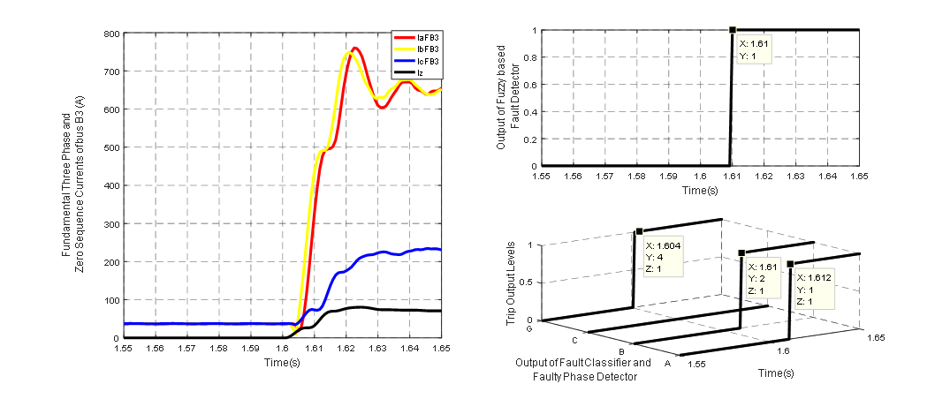
Fig.5 Test result of ABG fault in section S-34 at 9kms with Rf = 0.01Ω, ti = 1.6sec in GCM
(a)
(c)
(a) Fundamental three phase currents and zero sequence currents of bus-3 (b) Fault detection (c) Fault classification.

An ABG fault is considered in the line section-34 (S-34) at 9kms from bus-3 at 1.6sec fault inception time, and the test results attained are depicted in Fig.5. The Fig.5(a) shows the fundamental components of current signals of bus-3 which are the inputs to fuzzy based fault classifier. Fig.5(b) shows the output of fuzzy based fault detector which is low (0) prior to the fault inception at 1.6 sec, thereafter it goes high (1) after 1.61sec, thus the fault is detected in 10msec after the fault is incepted. Subsequently, Fig.5(c) shows the output of fuzzy based fault classifier in which the phases A, B gets high (1) after 11msec while C remains low (0) and G goes high (1) after 4msec, confirming that the fault type is LLG fault involving A, B phases and ground. Thus, the proposed scheme rapidly detects the fault and identifies the faulty phase.
  - Performance in case of Islanded Mode
The proposed scheme has also been evaluated in islanded mode of operation and is explained in this section. As the magnitude of current at various buses is very small as compared with grid connected mode, the protection task in this mode is taken care by using the fuzzy based adaptive fault classifier (i.e. FIS-3). For an ABC fault in islanded mode in the section-13 (S-13) at 18kms from bus-1 at 8secs, the Fig.6 demonstrates the obtained results of proposed scheme. The Fig.6 (a) shows the fundamental components of current signals of bus-3 which are the only inputs of the FIS-3 as the magnitudes of the current signals of bus-1 are zero for the islanded mode as the utility grid is disconnected. Fig.6 (b) exemplifies the output of fuzzy based fault detector which rises from 0 to 1 (high) after 8.009sec. Thus, the fault detection time is 9msec in this case. Fig.6(c) depicts the four output of fault classification i.e. the phases A, B, C which become high (1) after 8.007sec, 8.009sec, 8.009sec respectively and G remains low (0), which confirms that the fault type is three phase fault i.e. ABC fault. Thus, the proposed scheme correctly identifies the far end fault in the section-13 within 9msec of time.
(b)

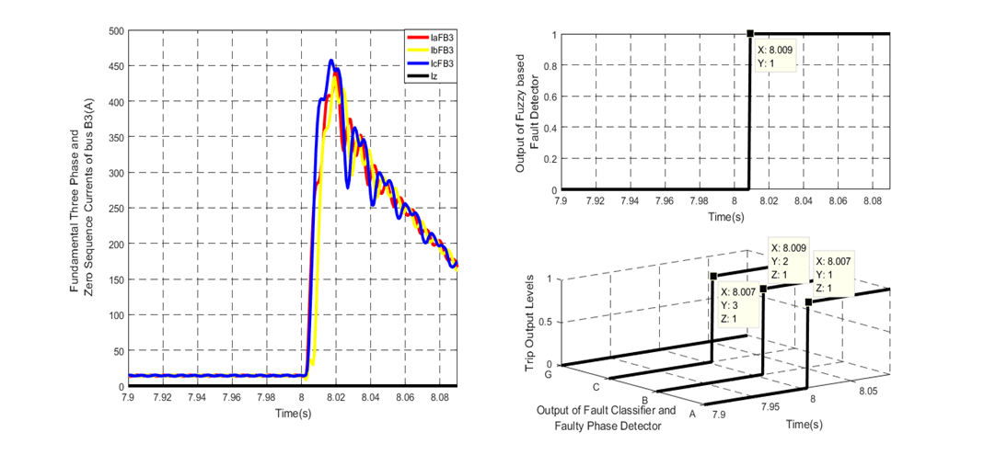
(a)
(c)
Fig.6 Test result of ABC fault in section S-13 at 18kms with Rf = 2Ω, ti = 8sec in IM
(a) Fundamental three phase currents and zero sequence currents of bus-3 (b) Fault detection (c) Fault classification.

  - Performance in case of Disconnection of DG unit
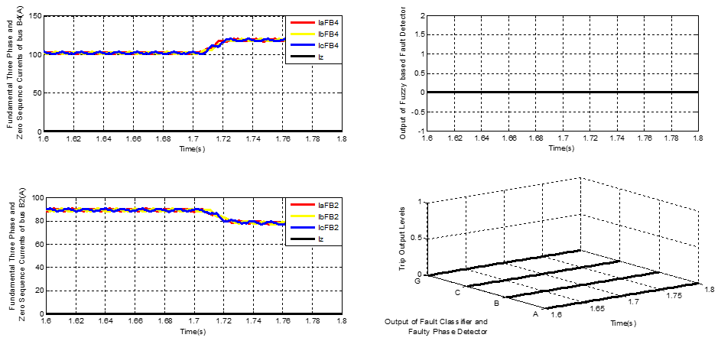
The performance of the proposed scheme has been tested for the disconnection of DG-2 (PV-1) of 1MW at bus-4 at time instant t = 1.7sec which should not have any impact on the prposed protection scheme. The test results attained are depicted in Fig.7 wherein The Fig.7(a) and Fig.7(b) show the fundamental components of current signals of bus-4 and bus-2 respectively as these two buses are nearer to the DG-2 which get mostly influenced by disconnection of the DG unit. Subsequently, Fig.7(c) shows the output of fault detector which remains low (0) throughout the simulation time. Further, Fig.7(d) shows the output of fuzzy based fault classifier which also remains low (0) and unaffected confirming that there is no fault in the system. Thus, it concludes that the proposed scheme is reliable and robust in case of disconnection of DGs also.
  - Performance in case of Load Variation
The performance of the proposed scheme has also been tested for sudden load variation, by adding a load-4 of 1MW, 0.2MVAR at bus-5 at 1.6s, which correspond to change in currents at bus-3 and bus-5. In this the performance of the proposed scheme is exemplified in Fig.8. The Fig.8(a) and Fig.8(b), showcase the fundamental components of current signals of bus-3 and bus-5 respectively wherein there is sudden change in all the three phase currents after 1.6s. Subsequently Fig.8(c) and Fig.8(d) show the outputs of fuzzy based fault detector and fault classifier respectively which remains low (0) and unaffected. Thus the results substantiate that, the proposed scheme is not affected by variation in load.

(c)
(a)

(b)
(d)
Fig.7 Test results for the disconnection of DG-2 (solar power PV-1) at time instant t = 1.7sec in GCM
(a) Fundamental three phase currents and zero sequence currents of bus-4 (b) Fundamental three phase currents and zero sequence currents of bus-2 (c) Output of fault detection (d) Output of fault classification
(b)
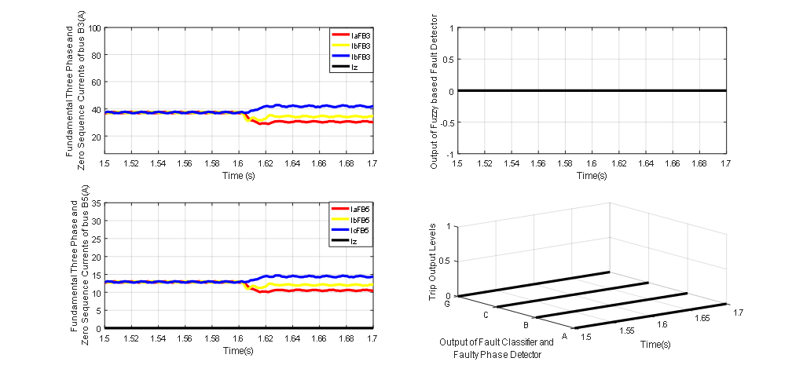
(b)
(d)
(a)
(b)
(c)
Fig.8 Test result in case of sudden increase in the load-4 at bus-5
(a)
(a) Fundamental three phase currents and zero sequence currents of bus-3
(b) Fundamental three phase currents and zero sequence currents of bus-5
(c) Output of fault detection (d) Output of fault classification.

Table 2. Comparative Assessment

Authored by |  | Techniques used | Fault Detec-tion | Fault Classifica-tion | Fault Phase Selec-tion | Grid-connect-ed mode | Islanded mode | Sampling Frequency | Operating Time | Fault type | FIA | Fault location
H. Nikkhajoei et. al. [12] |  | Sequence components | Yes | No | No | Detects | Detects | - | 2.5 cycles | LG, LL only | 0°-360° | -
E. Sortomme et. al. [10] |  | Communication assisted Differential currents | Yes | No | No | Detects | Detects | 960Hz | 1/8-1/4 cycle | LG only | - | At midpoint only
H.H, Zeineldin et. al. [15] |  | Differential currents | Yes | No | No | Detects | Detects | - | 3 cycles | - | 0°-180° | -
S. Kar et. al. [5] |  | S-Transform | Yes | No | No | Detects | Detects | 1.2 kHz | 4 cycles | 10 types | 0°-360° | 0-20km
A Gururani et. al. [6] |  | Hilbert- Transform | Yes | No | No | Detects | Detects | 1.2 kHz | 2 cycles | 10 types | 0°-360° | 0-20km
D.P. Mishra et. al. [7] |  | Combined Wavelet and Data Mining | Yes | Yes | No | Detects | Detects | 6.66 kHz | 1.5-2.5 cycles | 10 types | 0°-180° | At midpoint only
Proposed Scheme |  | Fuzzy based scheme | Yes | Yes | Yes | Detects | Detects | 1.2 kHz | ¼-1 cycle | 10 types | 0°-360° | 0-20km
 | ‘Yes’ = considered, ‘No’ = not considered, and ‘-‘ = not considered/mentioned

- Comparison with Existing Schemes
The proposed fuzzy based protective relaying scheme for microgrid has been compared with the recently reported protection schemes for microgrid. Comparison of different protection schemes with respect to different parameters and conditions is tabulated in Table III. It can be seen that, most of the techniques [5, 6, 10, 12, 15] are dealing with only fault detection issue, further only one scheme [7] classifies the fault but it does not identify the faulted phase, also it’s response time and sampling frequency is high and considers fault at midpoint of the line only. Further the proposed scheme detects the fault rapidly as compared to the other techniques. Moreover, the reliability of the proposed scheme is not affected for change in the operating mode of microgrid; it detects the fault and also identifies the fault type/faulty phases rapidly during grid connected and islanded modes of operation of microgrid.
- Summary/Conslusions
Owing to the fact that very limited research papers are available for protection of microgrid that too is limited to only fault detection issue. In this paper, a new fault detection, fault classification and faulty phase identification schemes for microgrid is presented. The technique is based on fundamental current signals only of all the terminals of the microgrid. The performance of the proposed technique has been evaluated by simulating a standard microgrid model IEC 61850-7-420 using MATLAB software package. The results clearly indicate that the presented technique is able to detect the fault correctly even when the fault is near the terminal points. At the same time, it is capable to identify the faulted phase and the type of fault. The proposed scheme also identifies whether the fault is present in utility grid or in microgrid so that the PCC disconnects the microgrid. The response time is within ¼-1 cycle even under wide variation in system and fault parameters. At the end, comparison of the proposed fuzzy inference system based protective relaying scheme with the existing technique shows its superiority. The complete protection scheme is very simple and is feasible for practical implementation as compared to other training based and conventional protection schemes.
References
- Yunwei Li, Farzam Nejabatkhah, ‘Overview of control, integration and energy management of microgrids’, J. Mod. Power Sys. Clean Energy (2014) 2(3):212-222.
- Hartono BS, Budiyanto, Rudy Setitabudy, ‘Review of Microgrid Technology’, IEEE Quality in Research 2013.
- Nikos D. Hatziargyriou, A.P. Sakis Meliopoulos, ‘Distributed Energy Sources: Technical Challenges’, IEEE, 2002.
- Iman Sadeghkhani, Mohamad Esmail Hamedani Golshan, Ali Mehrizi-Sani, Josep M. Guerrero, Abbas Ketabi, ‘Transient Monitoring Function–Based Fault Detection for Inverter-Interfaced Microgrids’, IEEE Transactions on Smart Grid, 2016.
- Susmita Kar, Subhransu Rajan Samantaray, ‘Time-Frequency Transform-Based Differential Scheme For Microgrid Protection’, IET Generation, Transmission & Distribution, 2013.
- Ashika Gururani, Soumya R. Mohanty, Jagadish Chandra Mohanta, ‘Microgrid Protection Using Hilbert–Huang Transform Based-Differential Scheme’, IET Generation, Transmission & Distribution, 2016.
- Debi Prasad Mishra, Subhransu Ranjan Samantaray, Geza Joos : ‘A Combined Wavelet and Data-Mining Based Intelligent Protection Scheme for Microgrid’, IEEE Transactions on Smart Grid, vol. 7, no. 5, 2016.
- Susmita Kar, R. Samantaray, M. Dadash Zadeh, ‘Data-Mining Model Based Intelligent Differential Microgrid Protection Scheme’, IEEE Systems Journal, 2015.
- Waleed K. A. Najy, H. H. Zeineldin, Wei Lee Woon, ‘Optimal Protection Coordination for Microgrids With Grid-Connected and Islanded Capability’, IEEE Transactions On Industrial Electronics, Vol. 60, No. 4, April 2013.
- Sortomme, E., Venkata, S.S., Mitra, J: ‘Microgrid protection using communication-assisted digital relays’, IEEE Trans. Power Deliv., 2012, 25, (4), pp. 2789–2796.
- M. Amin Zamani, Tarlochan S. Sidhu, Amirnaser Yazdani, ‘A Protection Strategy and Microprocessor-Based Relay for Low-Voltage Microgrids’, IEEE Transactions On Power Delivery, Vol. 26, No. 3, July 2011.
- Nikkhajoei, H., Lasseter, R.H.: ‘Microgrid protection’. IEEE Power Engineering Society General Meeting, June 2007, pp. 1–6.
- Uzoma Orji, Christopher Schantz, Steven B. Leeb, James L. Kirtley, Jr., Bart Sievenpiper, Katie Gerhard, Timothy McCoy, ‘Adaptive Zonal Protection for Ring Microgrids’, IEEE Transactions on Smart Grid, 2015.
- Harikrishna Muda, Premalata Jena, ‘Superimposed Adaptive Sequence Current Based Microgrid Protection: A New Technique’, IEEE Transactions on Power Delivery, 2016.
- Zeineldin, H.H., El-Saadany, E.F., Salama, M.M.A.: ‘Distributed generation microgrid operation: control and protection’. Proc. Power Syst. Conf., March 2006, pp. 105–112.
- E. Casagrande, W. L., H. H. Zeineldin, D. Svetinovic, ‘A Differential Sequence Component Protection Scheme for Microgrids With Inverter-Based Distributed Generators’, IEEE Transactions On Smart Grid, Vol. 5, No. 1, January 2014.
- Taha Selim Ustun, Cagil Ozansoy, Aladin Zayegh, ‘Fault Current Coefficient and Time Delay Assignment for Microgrid Protection System With Central Protection Unit’, IEEE Transactions On Power Systems, Vol. 28, No. 2, May 2013.
- Shuping Cai, Guohai Liu, “Study on Application of Fisher Information * for Power System Fault Detection”, Accepted manuscript, Journal of Power Technology, pp. 692-701.
- S. Mojtahedzadeh, S. N. Ravadanegh, M.R. Haghifam, “A framework for optimal clustering of a greenfield distribution network area into multiple autonomous microgrids”, Journal of Power Technology, Vol 96, No 4 (2016), pp 219-228.
- T.S. Ustun, C.Ozansoy, A. Zayegh: ‘Modeling of a centralized microgrid protection system and distributed energy resources according to IEC 61850–7-420’, IEEE Trans. Power Syst., 2012, 27, (3), pp. 1560–1567.

